Segment-Length Equality
# Source: AI Source: Provided by: [Data Path: Persons Table -> ID Column: 1, Name_En Column: Motasem Essam] -> From: [ChatGPT] on [7/25/2026]
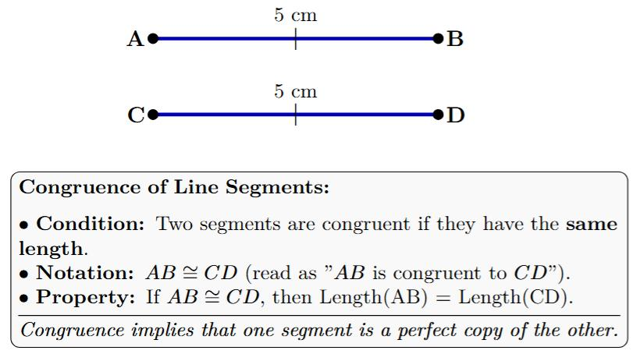
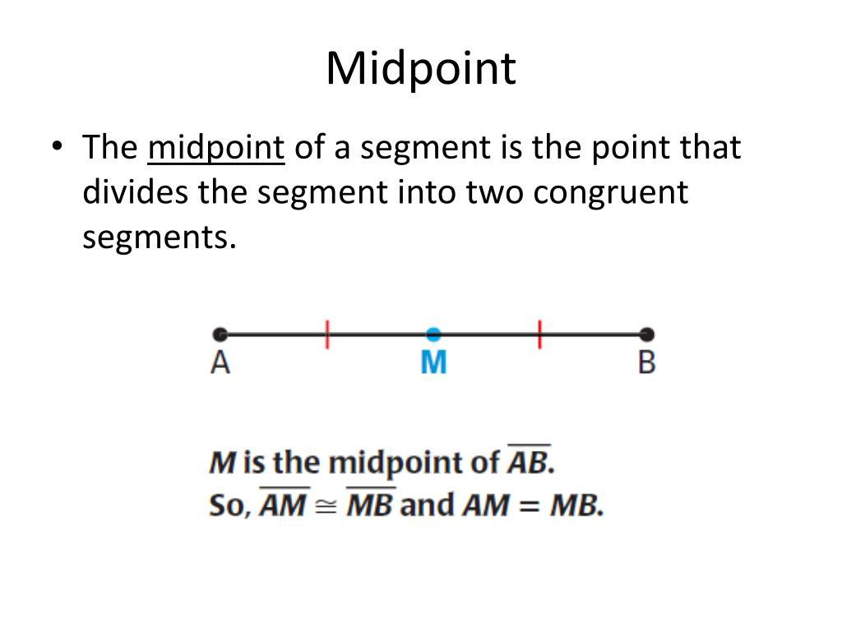
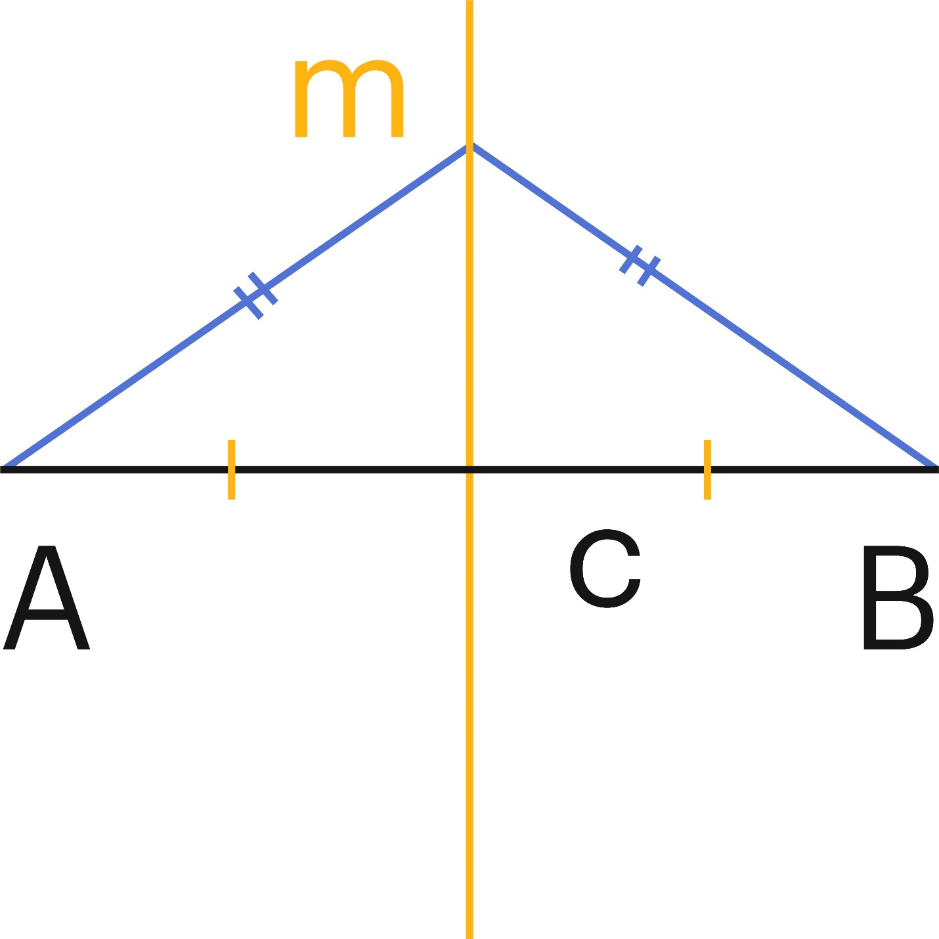
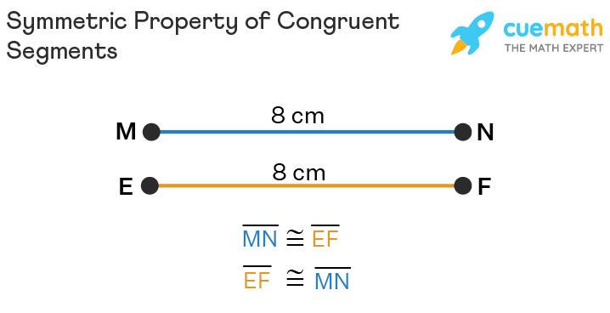
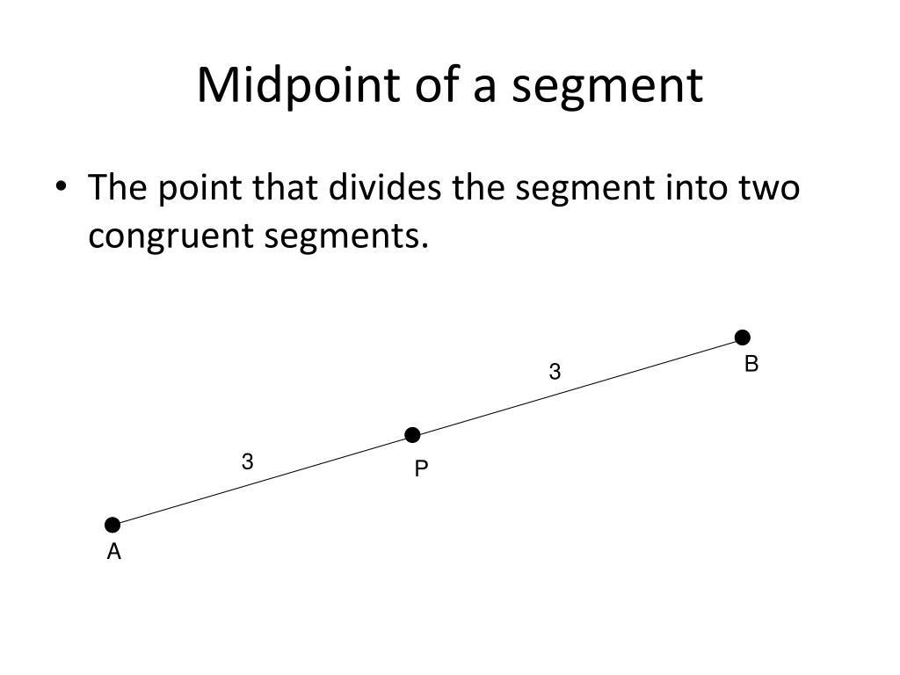
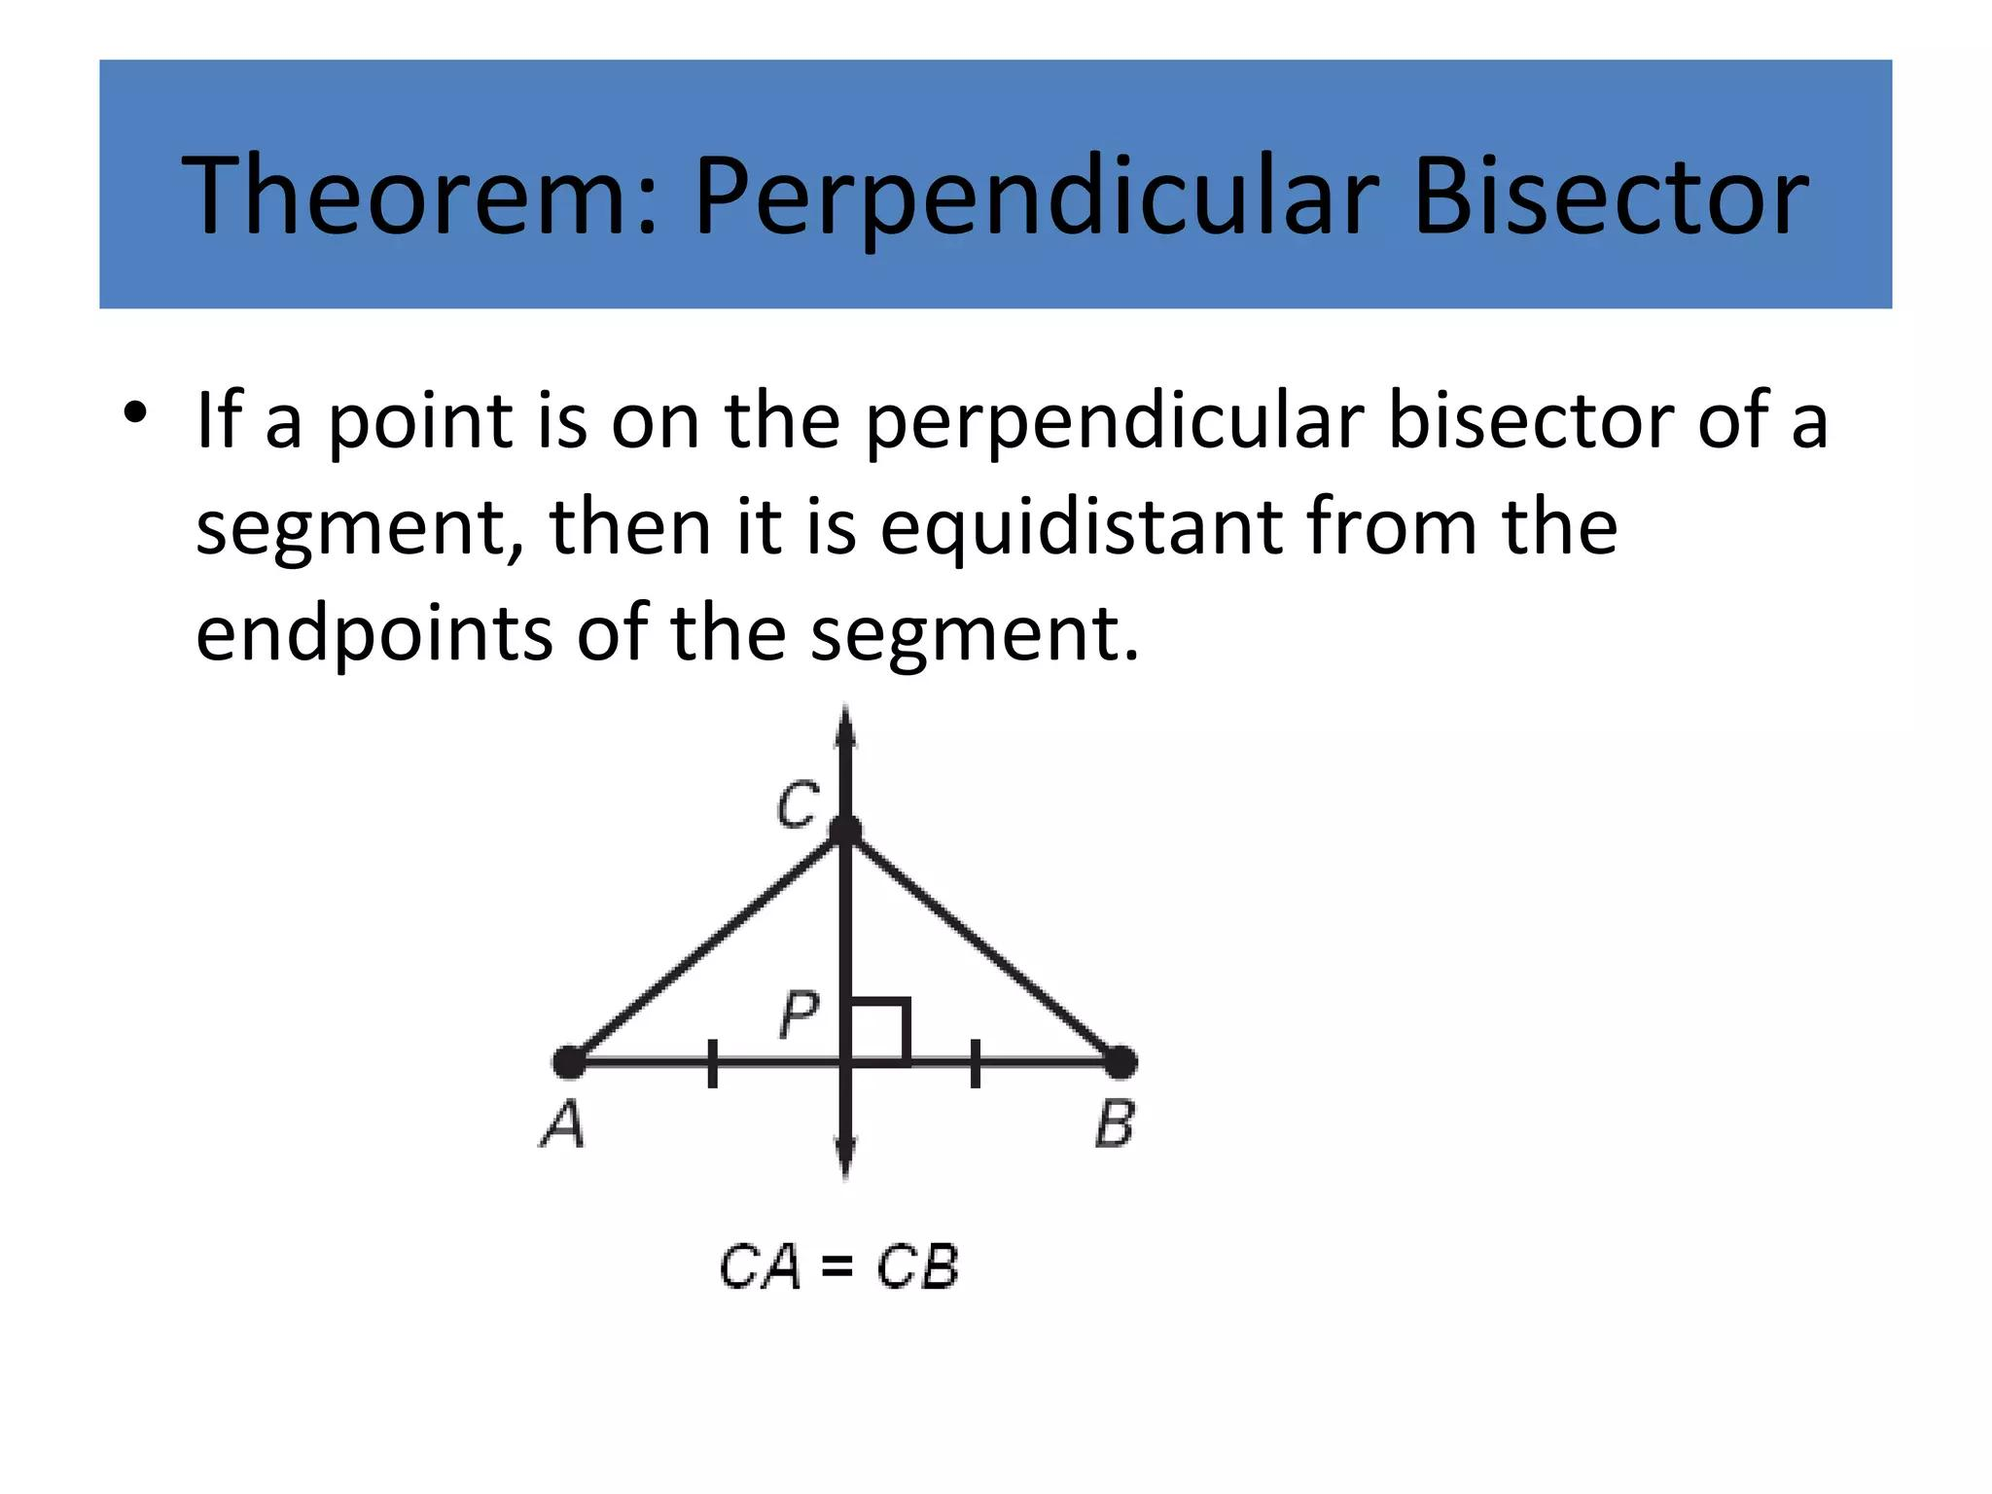

Definition
# Source: AI Source: Provided by: [Data Path: Persons Table -> ID Column: 1, Name_En Column: Motasem Essam] -> From: [ChatGPT] on [7/25/2026]
Segment-Length Equality is a geometric equality stating that two or more line segments have exactly the same length.
If segments $\overset{‾}{AB}$and $\overset{‾}{CD}$have equal lengths, we write:
$$\boxed{AB=CD}$$
This means their lengths are equal, not necessarily that the segments occupy the same location or are the same geometric object.

Simple Definition
# Source: AI Source: Provided by: [Data Path: Persons Table -> ID Column: 1, Name_En Column: Motasem Essam] -> From: [ChatGPT] on [7/25/2026]
Segment-Length Equality means that two line segments have the same length.
For example:
$$AB=CD=5\text{ cm}$$
means both segments have length $5$cm.
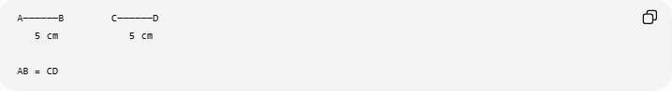
A──────B C──────D
5 cm 5 cm

AB = CD
The segments can have different positions and directions while still having equal lengths.

Fundamental Concept
# Source: AI Source: Provided by: [Data Path: Persons Table -> ID Column: 1, Name_En Column: Motasem Essam] -> From: [ChatGPT] on [7/25/2026]
The basic relationship is:
$$\boxed{\overset{‾}{AB}\text{ and }\overset{‾}{CD}\text{ have equal lengths}}$$
or simply:
$$\boxed{AB=CD}$$
Segment-length equality compares a numerical measurement.
For example:
$$AB=7$$
and:
$$CD=7$$
therefore:
$$\boxed{AB=CD}$$

Main Types of Segment-Length Equality
# Source: AI Source: Provided by: [Data Path: Persons Table -> ID Column: 1, Name_En Column: Motasem Essam] -> From: [ChatGPT] on [7/25/2026]
A practical classification is:
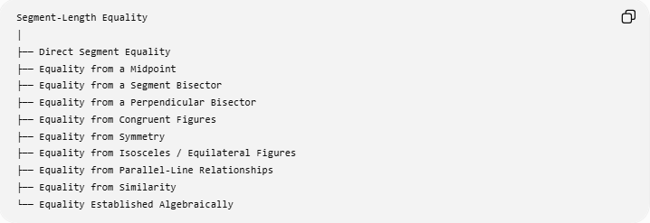
Segment-Length Equality
│
├── Direct Segment Equality
├── Equality from a Midpoint
├── Equality from a Segment Bisector
├── Equality from a Perpendicular Bisector
├── Equality from Congruent Figures
├── Equality from Symmetry
├── Equality from Isosceles / Equilateral Figures
├── Equality from Parallel-Line Relationships
├── Equality from Similarity
└── Equality Established Algebraically
These are ways in which segment-length equality can arise or be established, rather than universally standardized subtypes.

Direct Segment-Length Equality
# Source: AI Source: Provided by: [Data Path: Persons Table -> ID Column: 1, Name_En Column: Motasem Essam] -> From: [ChatGPT] on [7/25/2026]
Definition
Two segments are directly stated or given to have equal lengths.
For example:
$$AB=CD.$$
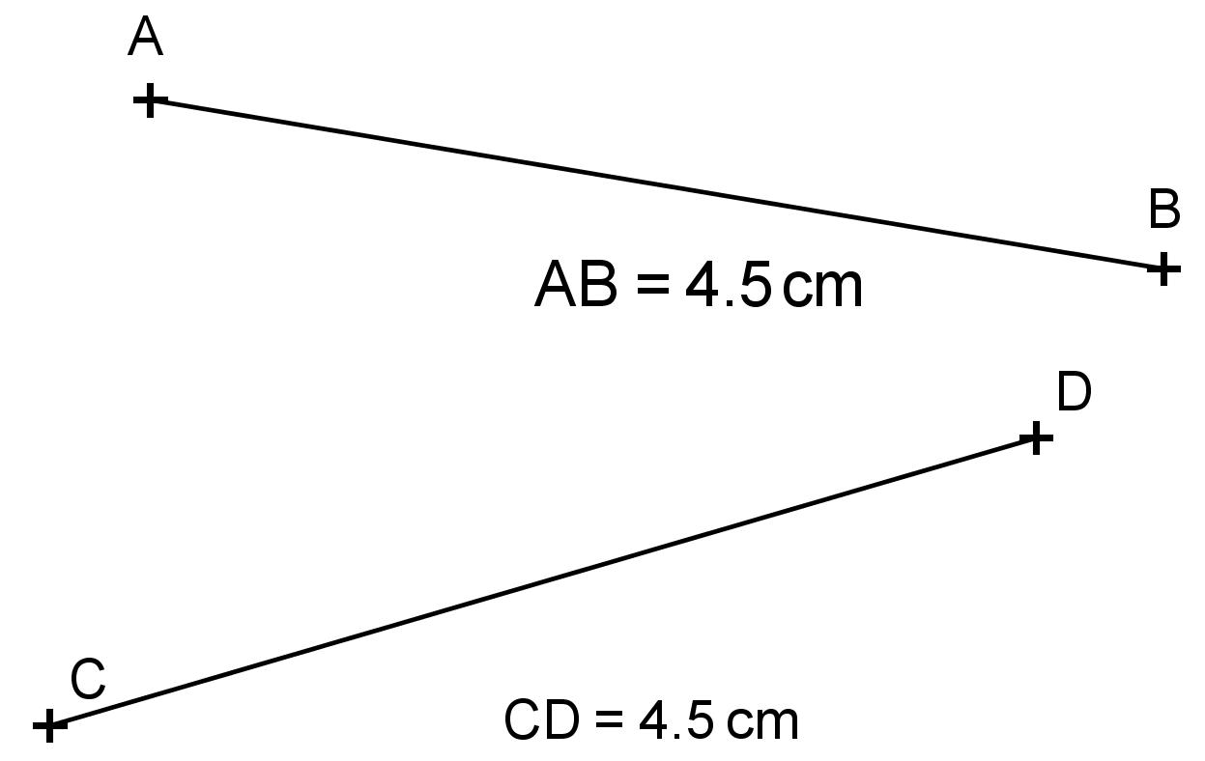
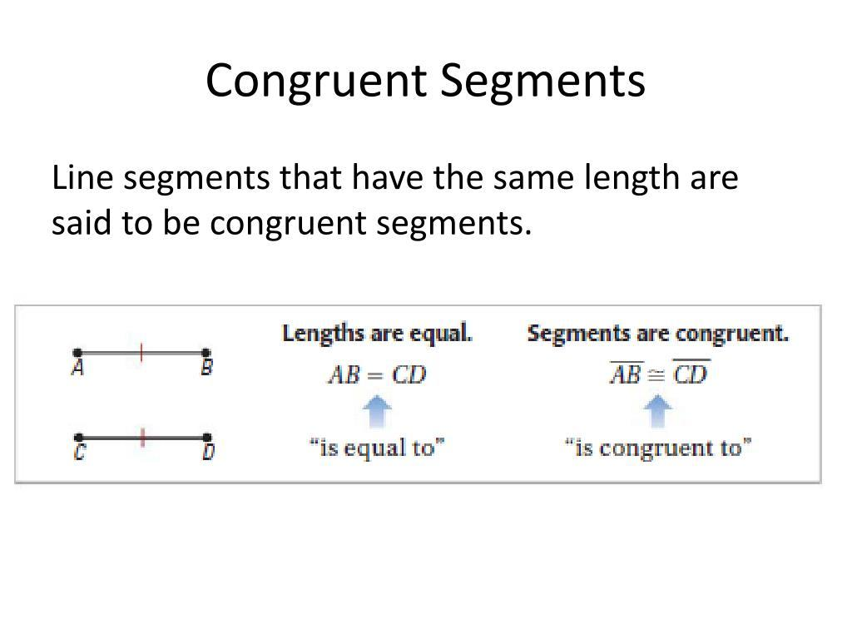
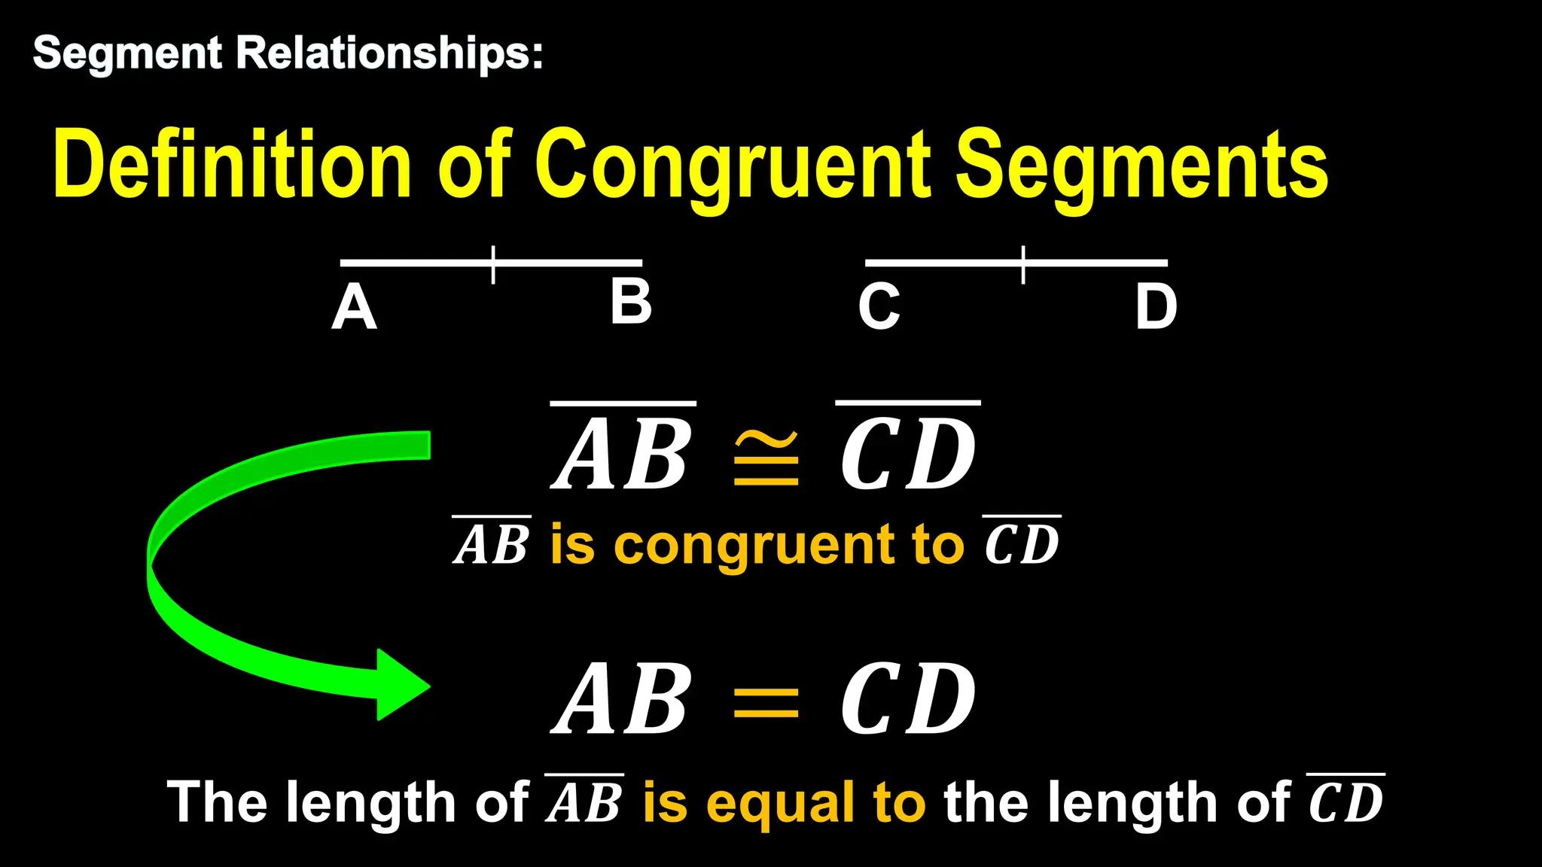
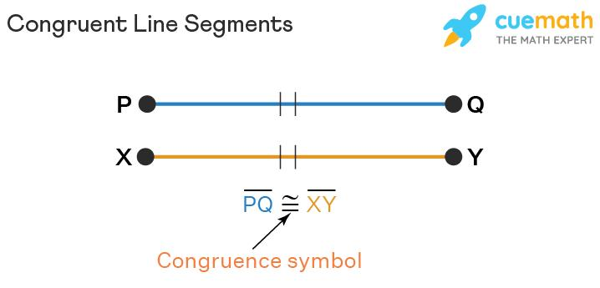
Example
Given:
$$AB=8\text{ cm}$$
and:
$$CD=8\text{ cm}.$$
Therefore:
$$\boxed{AB=CD}$$
No additional theorem is needed because the equality is given.

Equality from a Midpoint
# Source: AI Source: Provided by: [Data Path: Persons Table -> ID Column: 1, Name_En Column: Motasem Essam] -> From: [ChatGPT] on [7/25/2026]
Definition
A midpoint divides a segment into two equal-length segments.
If $M$is the midpoint of $\overset{‾}{AB}$, then:
$$\boxed{AM=MB}$$
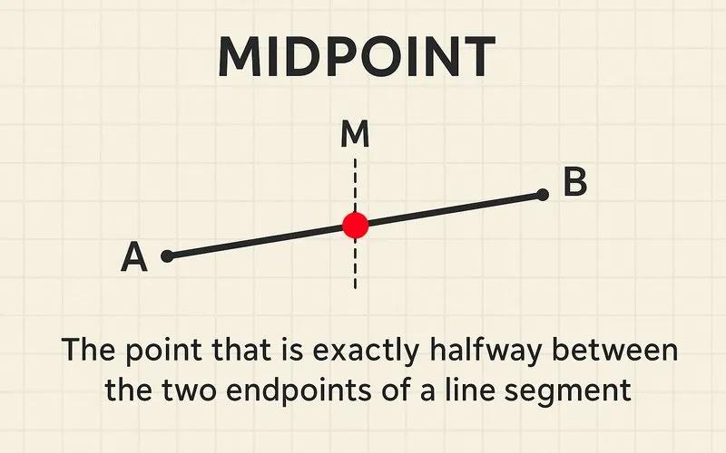
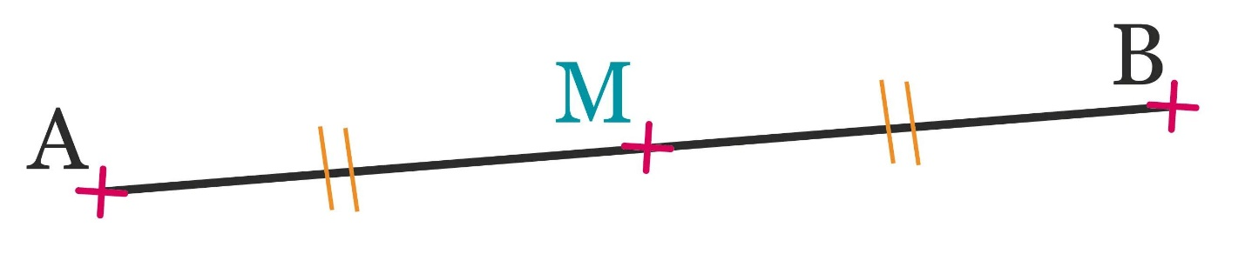
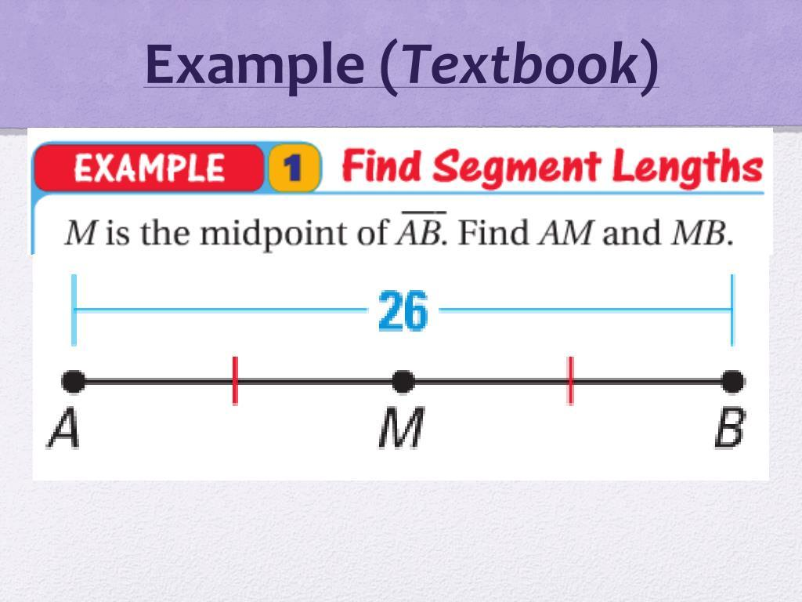
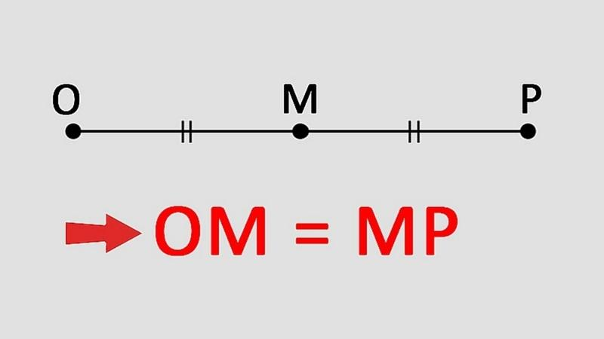
Example
If:
$$AB=12\text{ cm}$$
and $M$is the midpoint, then:
$$AM=MB$$
and:
$$AM=MB=6\text{ cm}.$$
Therefore:
$$\boxed{AM=MB=6\text{ cm}}$$
Important
The midpoint definition includes both:
$$A,M,B\text{ are collinear}$$
and:
$$\boxed{AM=MB}.$$

Equality from a Segment Bisector
# Source: AI Source: Provided by: [Data Path: Persons Table -> ID Column: 1, Name_En Column: Motasem Essam] -> From: [ChatGPT] on [7/25/2026]
Definition
A segment bisector is a line, ray, segment, or other geometric object that passes through the midpoint of a segment and therefore divides it into two equal parts.
If a bisector intersects $\overset{‾}{AB}$at $M$, then:
$$\boxed{AM=MB}$$
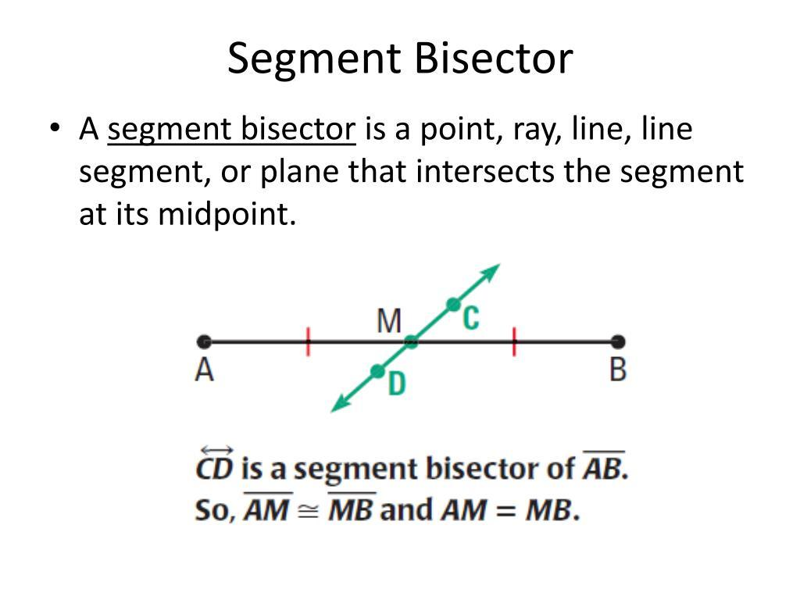
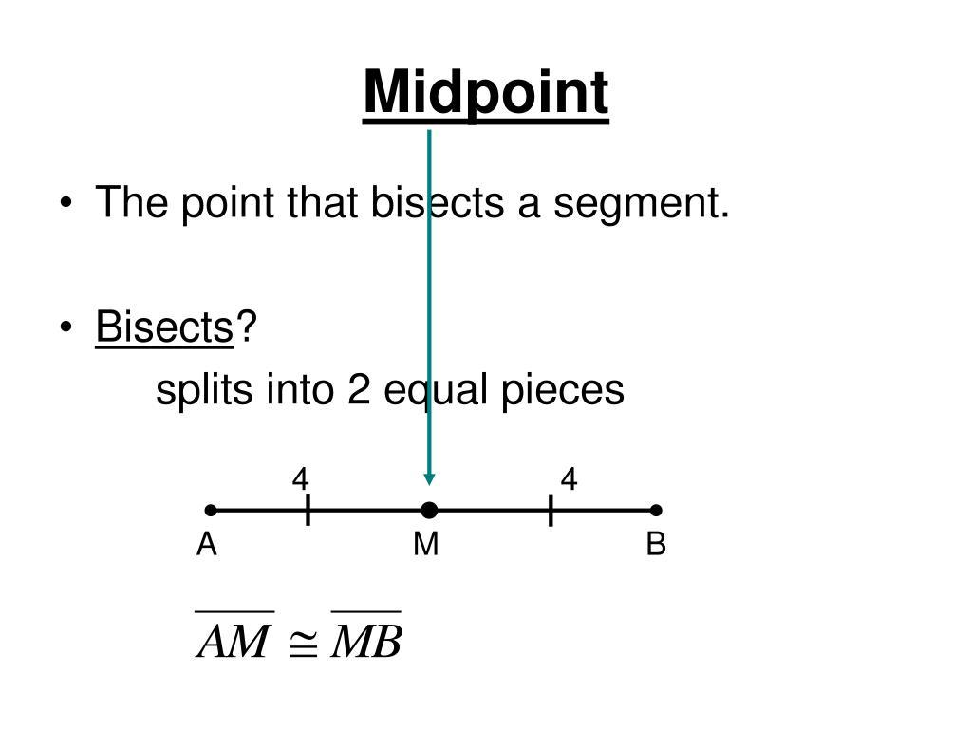
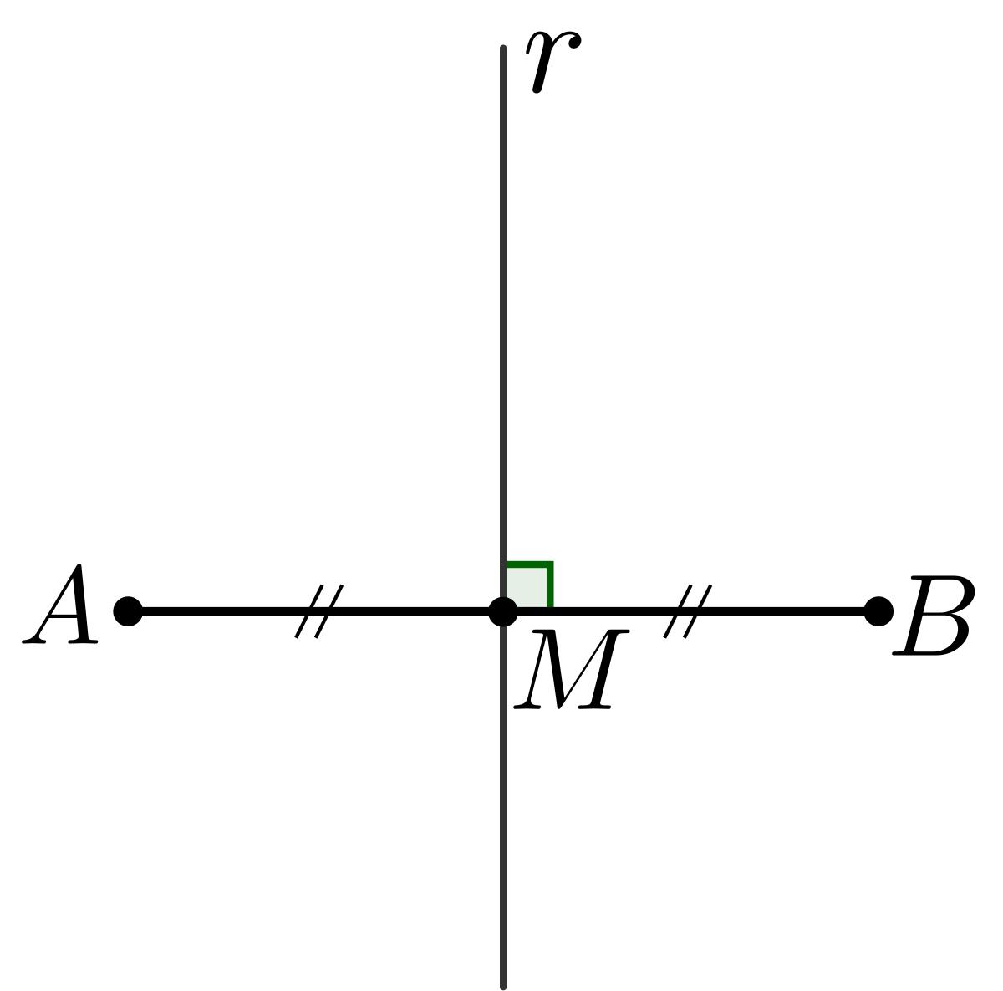
For example:
$$AM=5\text{ cm}$$
and:
$$MB=5\text{ cm}.$$
Therefore:
$$\boxed{AM=MB}.$$

Equality from a Perpendicular Bisector
# Source: AI Source: Provided by: [Data Path: Persons Table -> ID Column: 1, Name_En Column: Motasem Essam] -> From: [ChatGPT] on [7/25/2026]
Definition
A perpendicular bisector divides a segment into two equal parts while being perpendicular to that segment.
If line $l$is the perpendicular bisector of $\overset{‾}{AB}$, and:
$$M=l∩AB,$$
then:
$$\boxed{AM=MB}$$
and:
$$\boxed{l⊥AB}.$$
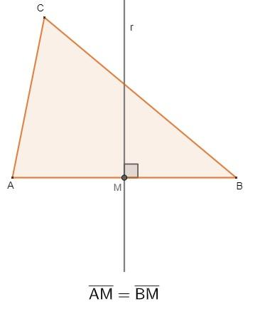
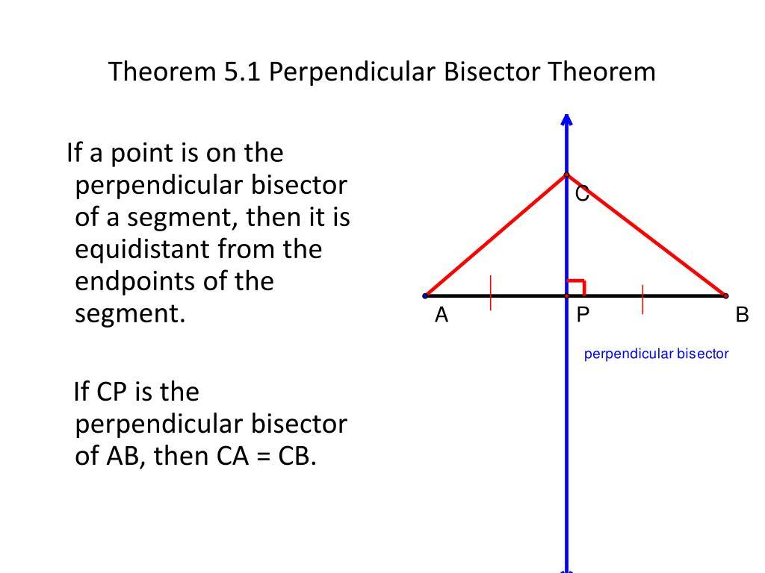
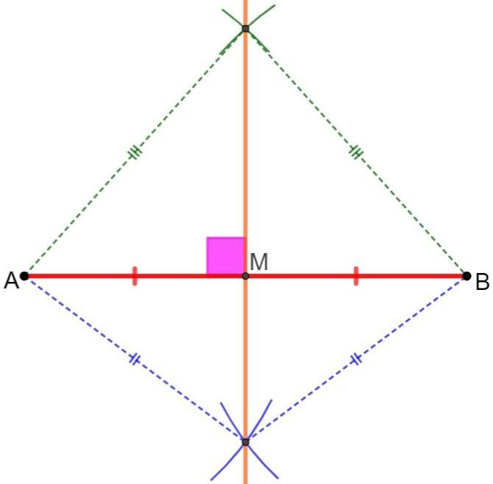
Example
If:
$$AB=20\text{ cm}$$
then its perpendicular bisector intersects it at:
$$AM=MB=10\text{ cm}.$$

Equality from Equidistance
# Source: AI Source: Provided by: [Data Path: Persons Table -> ID Column: 1, Name_En Column: Motasem Essam] -> From: [ChatGPT] on [7/25/2026]
A perpendicular bisector also creates equality of distances from points to the endpoints.
If $P$lies on the perpendicular bisector of $\overset{‾}{AB}$, then:
$$\boxed{PA=PB}$$
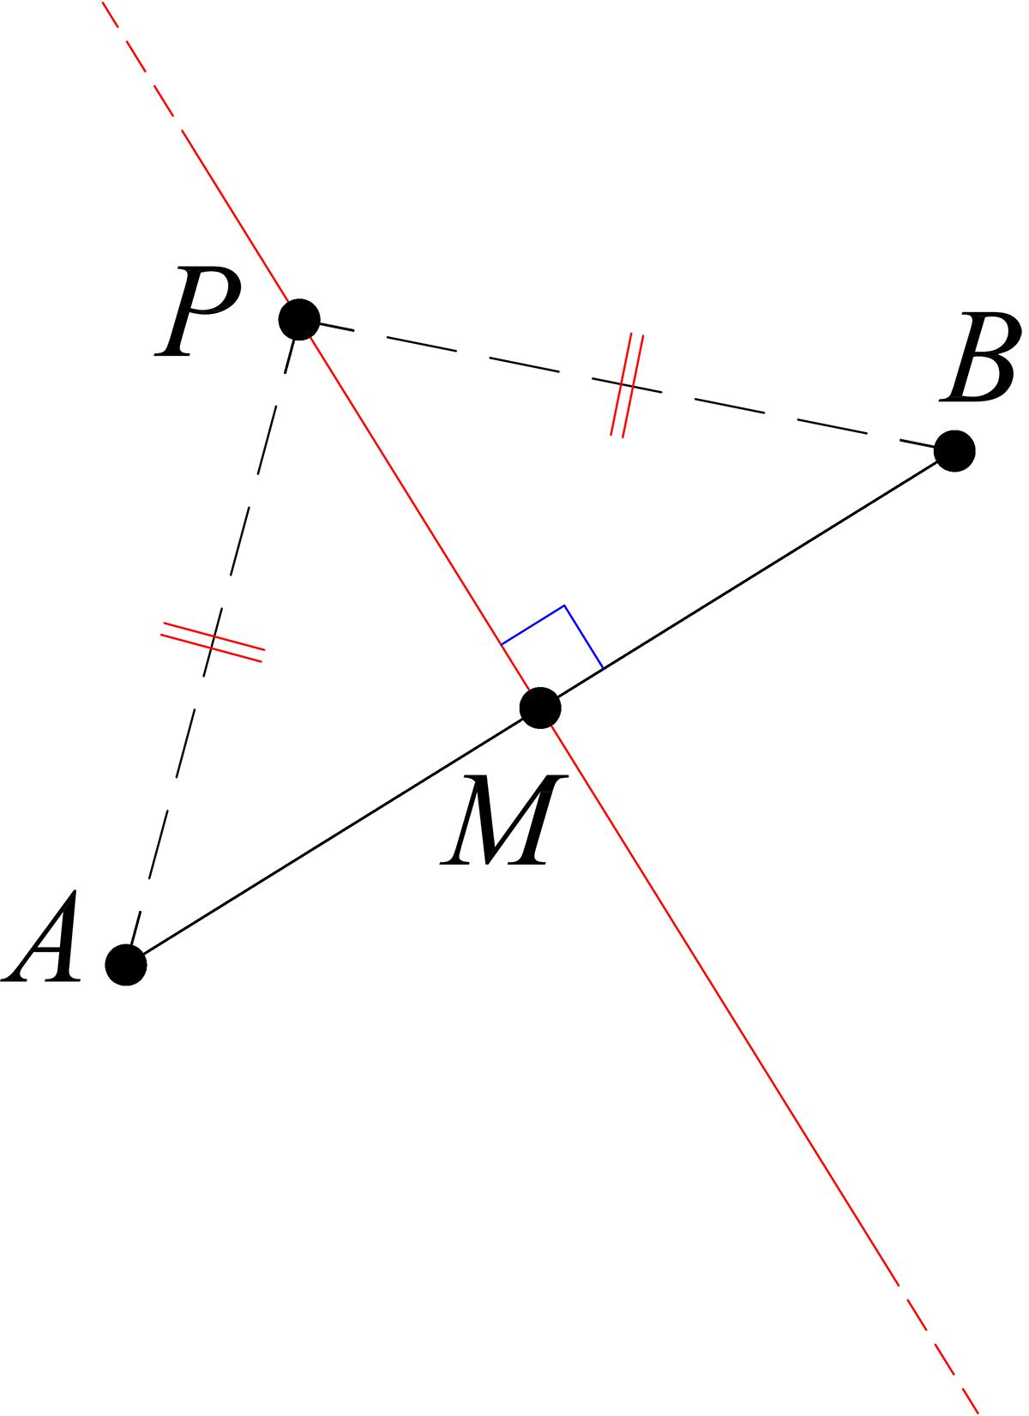
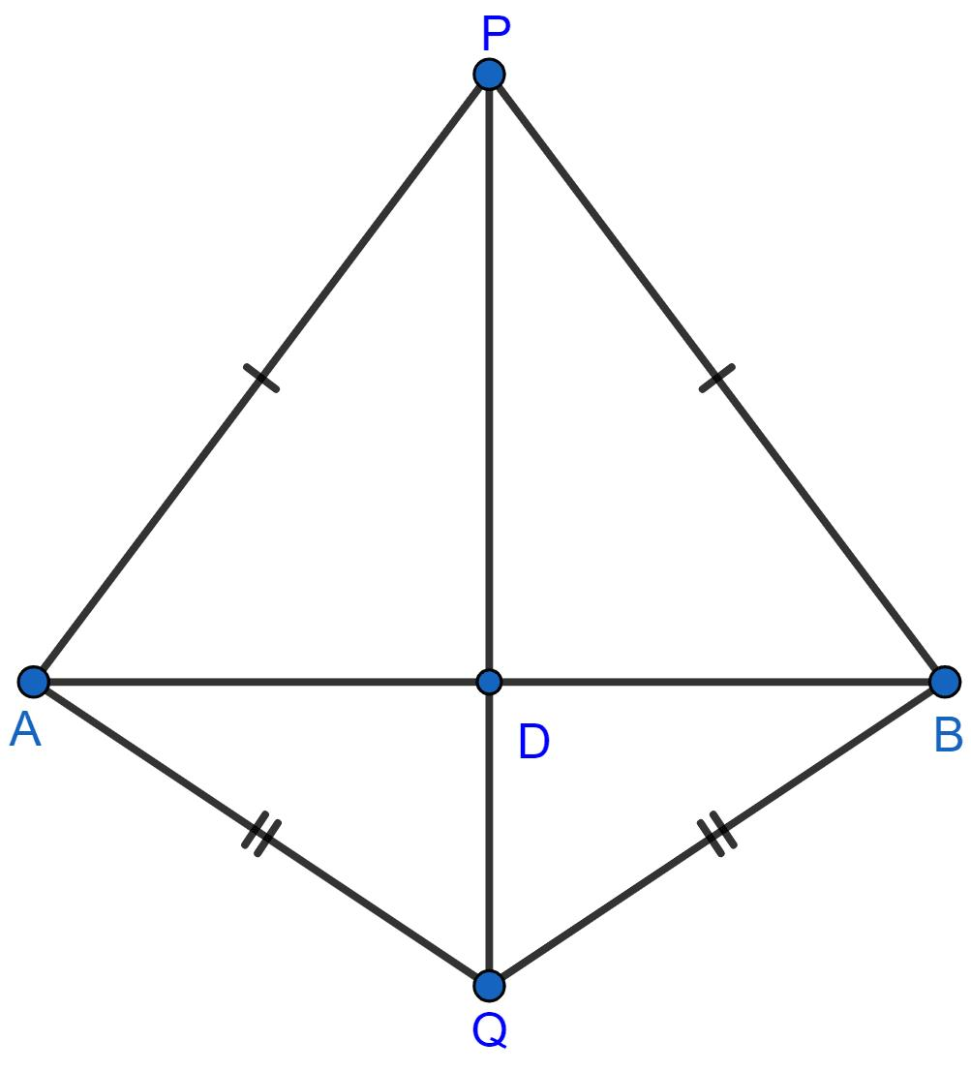
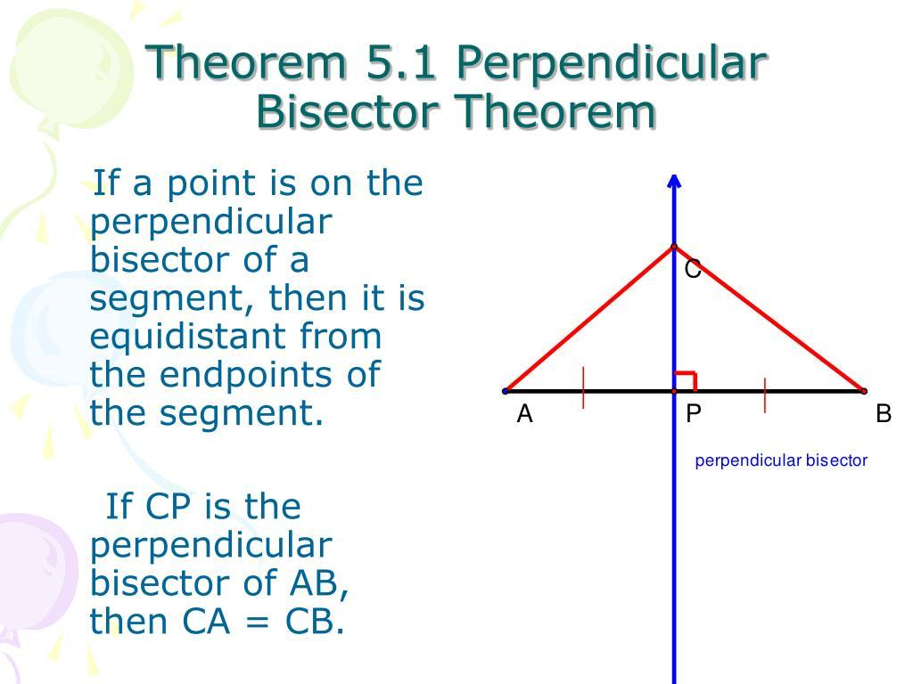
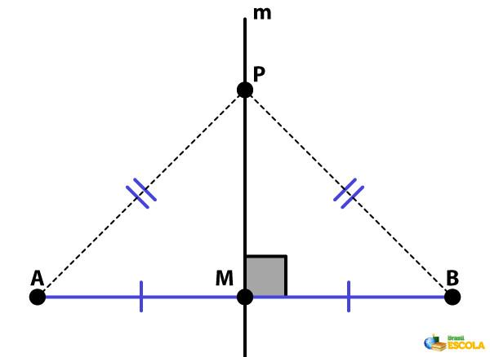
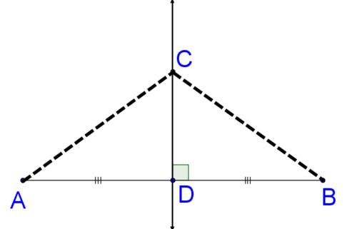
For example:
$$PA=7\text{ cm}$$
then:
$$PB=7\text{ cm}.$$
This is an important connection between:
$$\boxed{\text{Segment-Length Equality}}$$
and:
$$\boxed{\text{Loci}}$$
because the perpendicular bisector is the locus of points equidistant from $A$and $B$.

Equality from Congruent Segments
# Source: AI Source: Provided by: [Data Path: Persons Table -> ID Column: 1, Name_En Column: Motasem Essam] -> From: [ChatGPT] on [7/25/2026]
Two segments are congruent if they have equal lengths.
For line segments:
$$\boxed{\overset{‾}{AB}≅\overset{‾}{CD}}$$
means:
$$\boxed{AB=CD}.$$
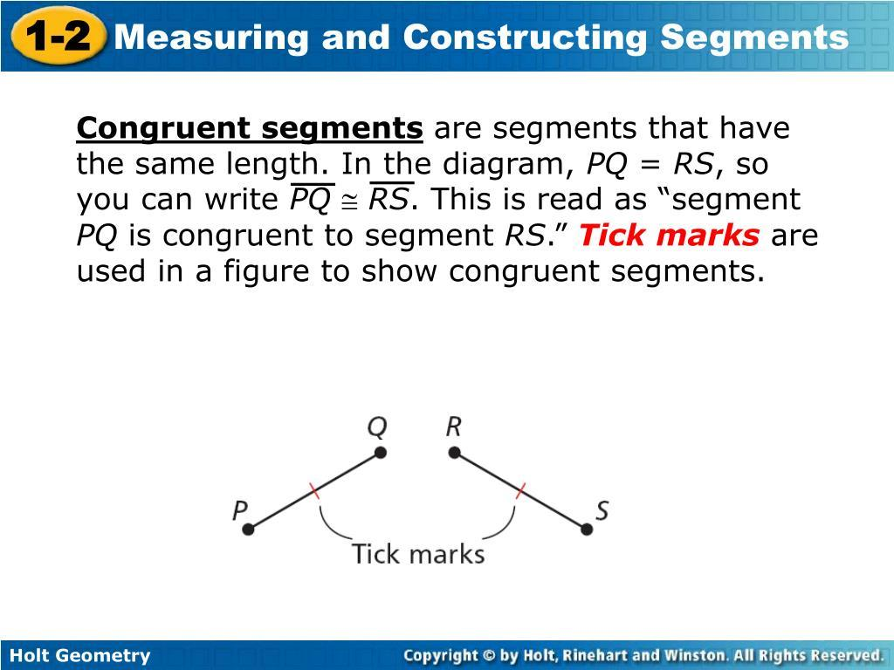
Important distinction
$$AB=CD$$
compares their lengths.
Whereas:
$$\overset{‾}{AB}≅\overset{‾}{CD}$$
states that the two segments are congruent geometric objects.
For line segments, these statements are directly equivalent in Euclidean geometry.

Equality from Isosceles Triangles
# Source: AI Source: Provided by: [Data Path: Persons Table -> ID Column: 1, Name_En Column: Motasem Essam] -> From: [ChatGPT] on [7/25/2026]
In an isosceles triangle, two sides have equal lengths.
If:
$$AB=AC,$$
then $△ABC$is isosceles.
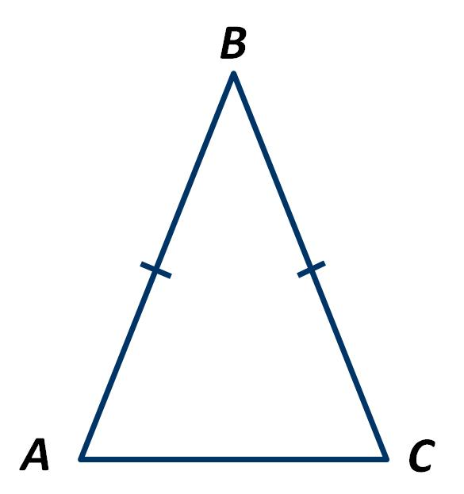
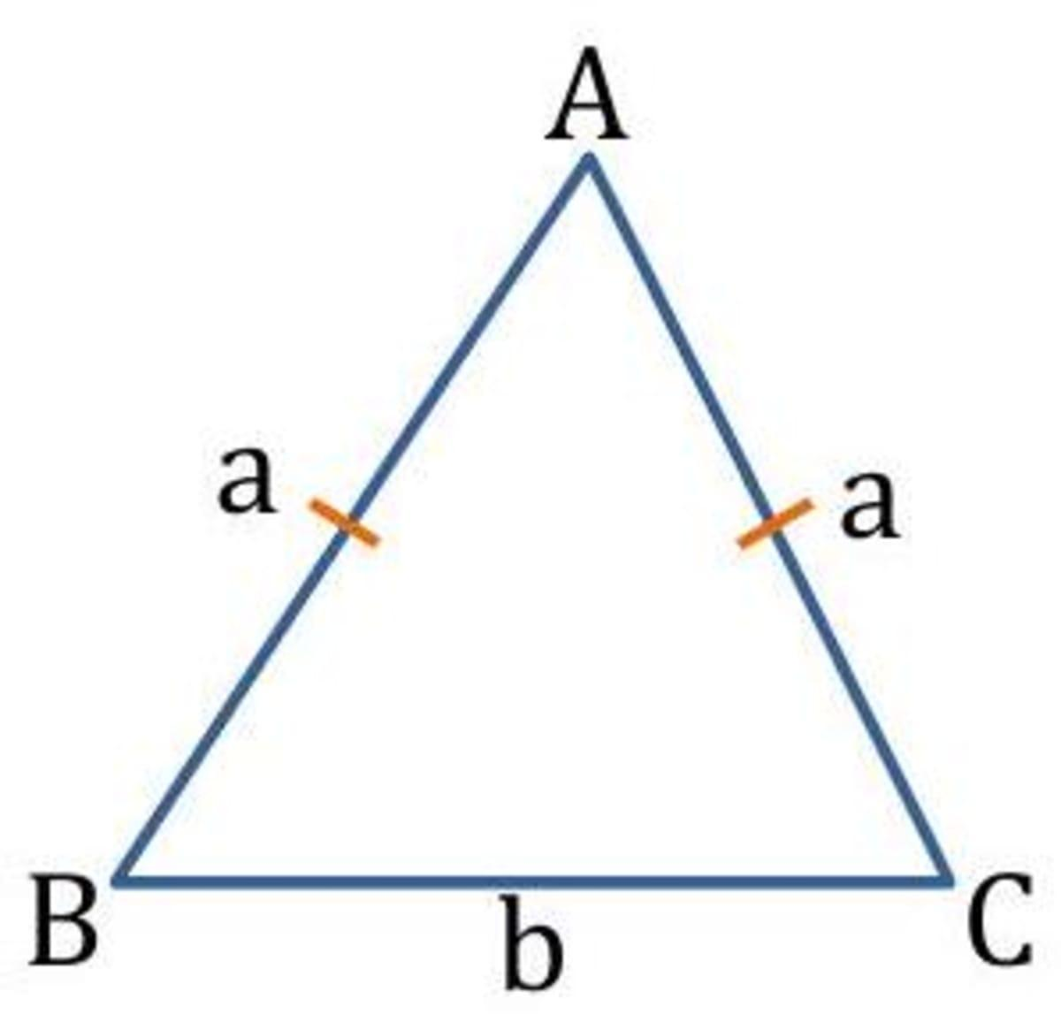
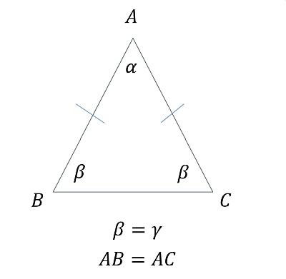
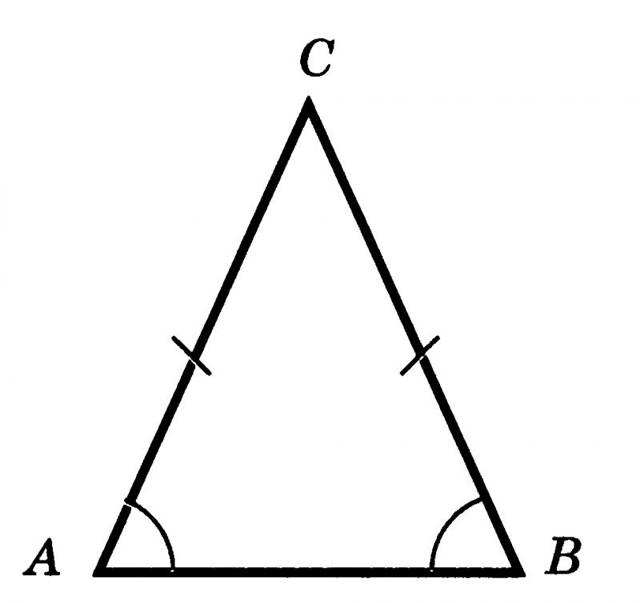
For example:
$$AB=10\text{ cm}$$
and:
$$AC=10\text{ cm}.$$
Therefore:
$$\boxed{AB=AC}.$$
This is a common source of segment-length equality.

Equality from Equilateral Triangles
# Source: AI Source: Provided by: [Data Path: Persons Table -> ID Column: 1, Name_En Column: Motasem Essam] -> From: [ChatGPT] on [7/25/2026]
An equilateral triangle has all three sides equal.
If $△ABC$is equilateral:
$$\boxed{AB=BC=CA}$$
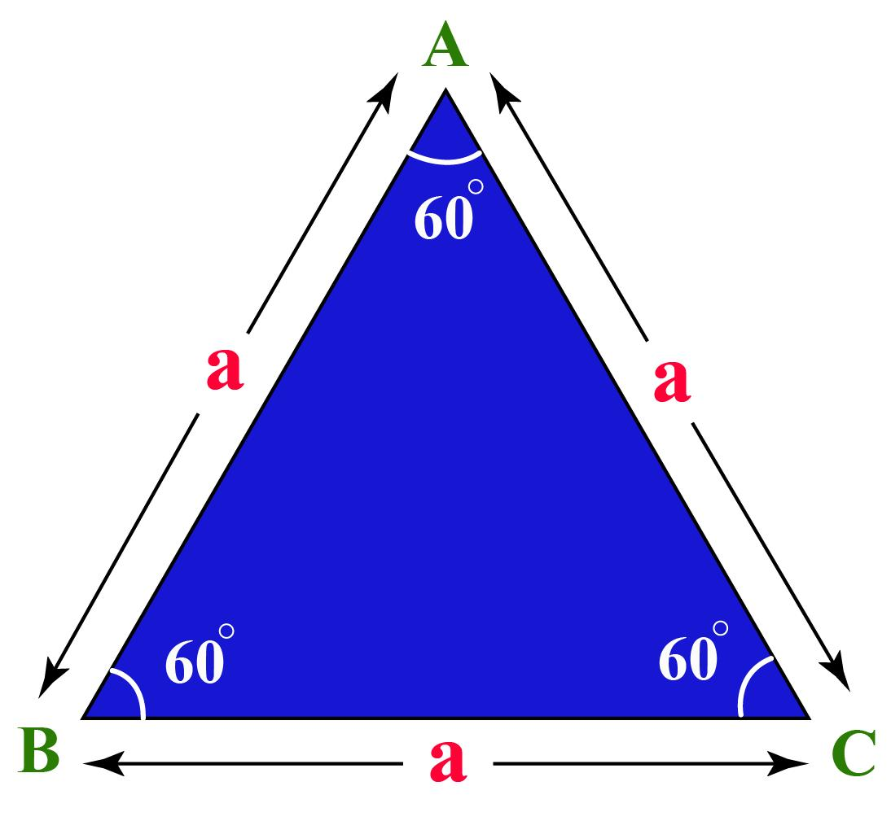
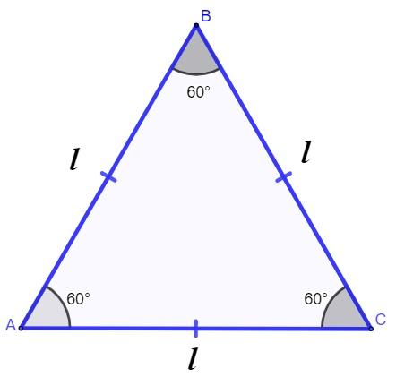
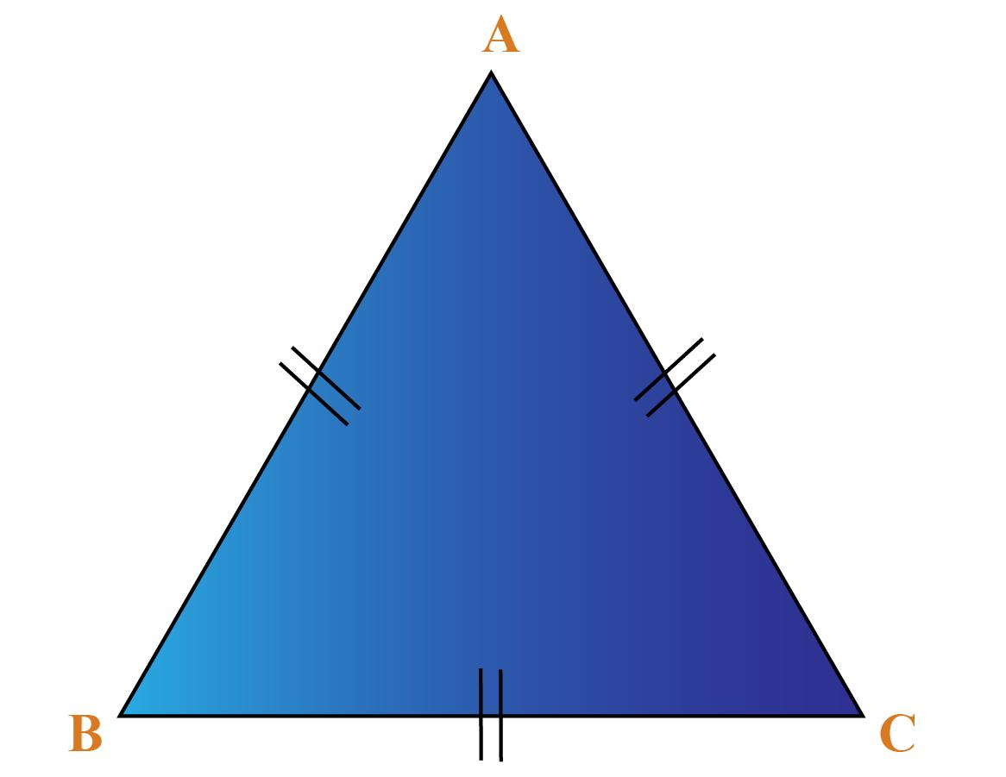
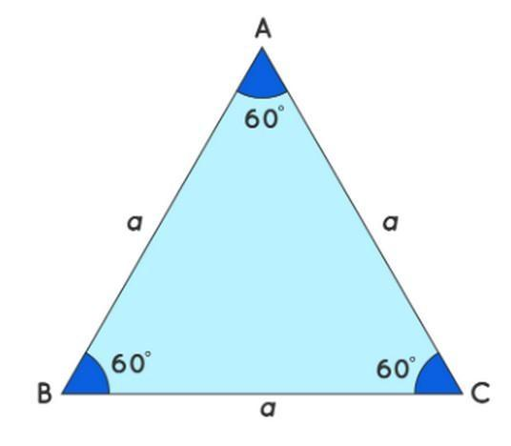
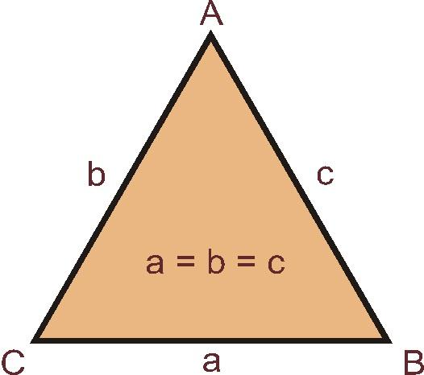
For example, if:
$$AB=6\text{ cm},$$
then:
$$\boxed{AB=BC=CA=6\text{ cm}}.$$

Equality from Congruent Triangles
# Source: AI Source: Provided by: [Data Path: Persons Table -> ID Column: 1, Name_En Column: Motasem Essam] -> From: [ChatGPT] on [7/25/2026]
If two triangles are congruent:
$$△ABC≅△DEF,$$
then corresponding sides have equal lengths.
For example:
$$\boxed{AB=DE} \\ \boxed{BC=EF} \\ \boxed{AC=DF}.$$
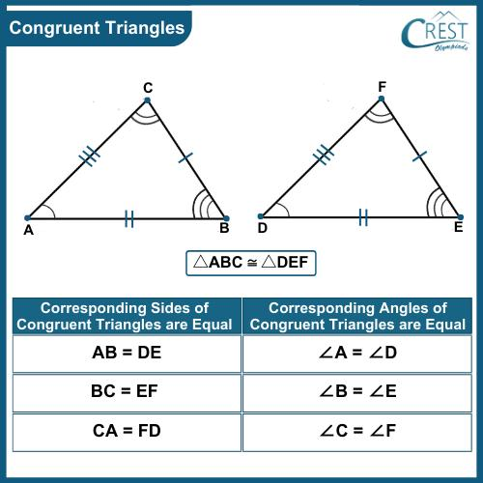
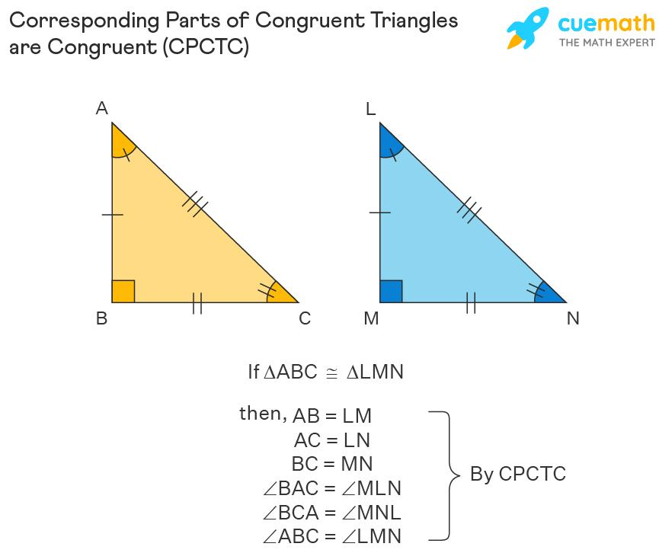
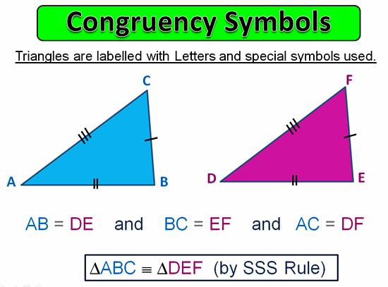
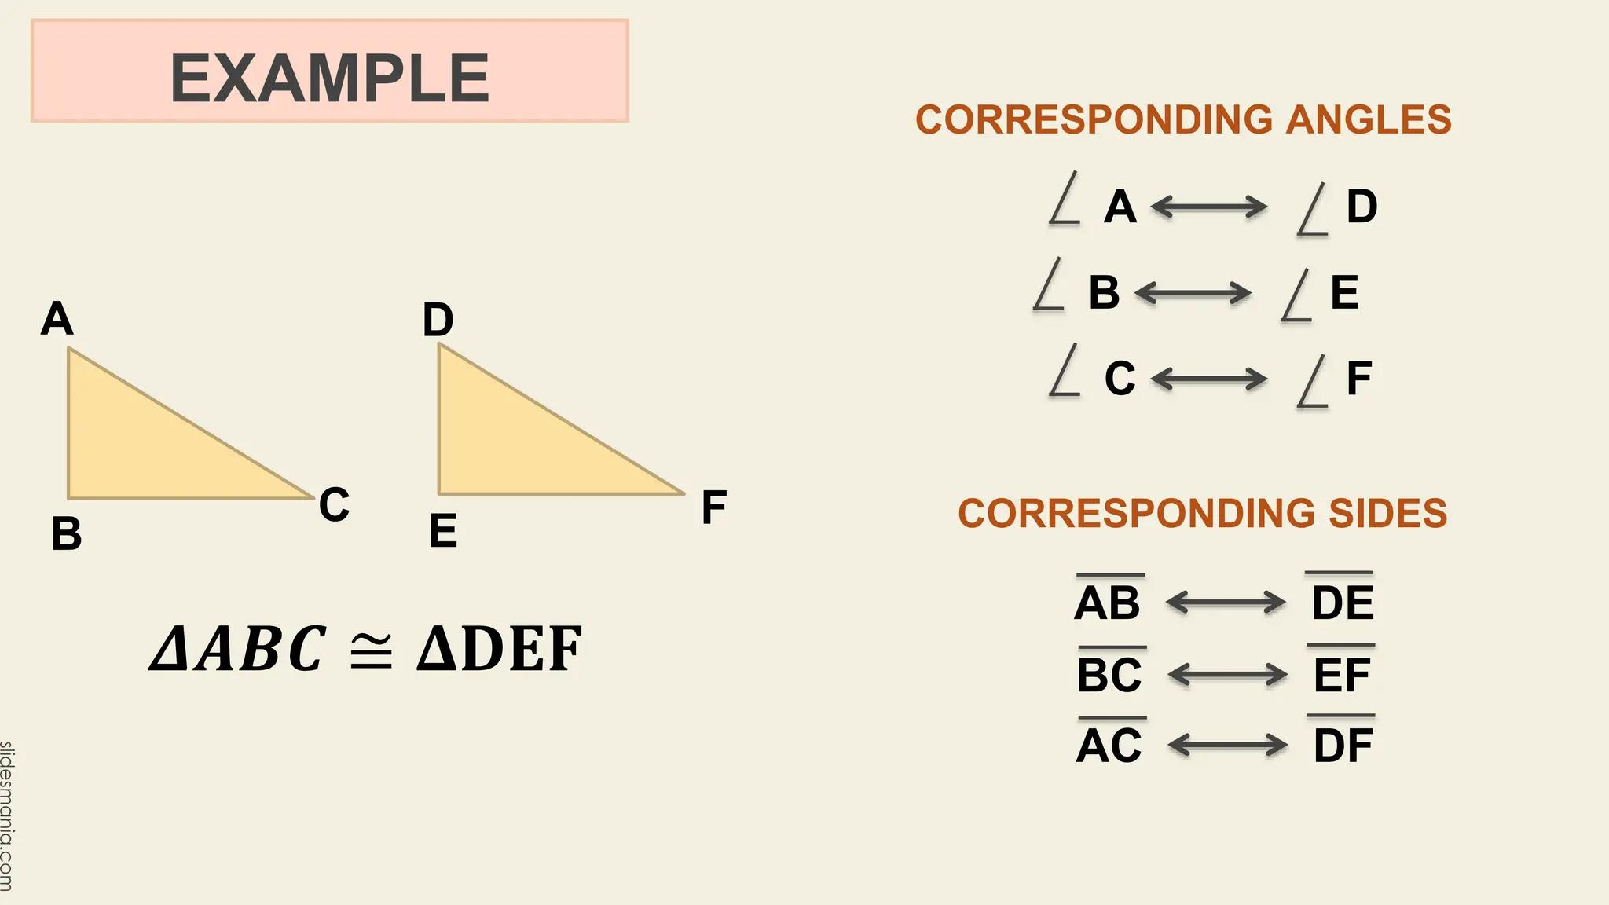
This follows from CPCTC:
Corresponding Parts of Congruent Triangles are Congruent.
Thus:
$$\boxed{\text{Congruence}→\text{Segment-Length Equality}}$$

Equality from Symmetry
# Source: AI Source: Provided by: [Data Path: Persons Table -> ID Column: 1, Name_En Column: Motasem Essam] -> From: [ChatGPT] on [7/25/2026]
Symmetry can create equal segment lengths.
For example, reflection symmetry can map one segment to another while preserving distance.
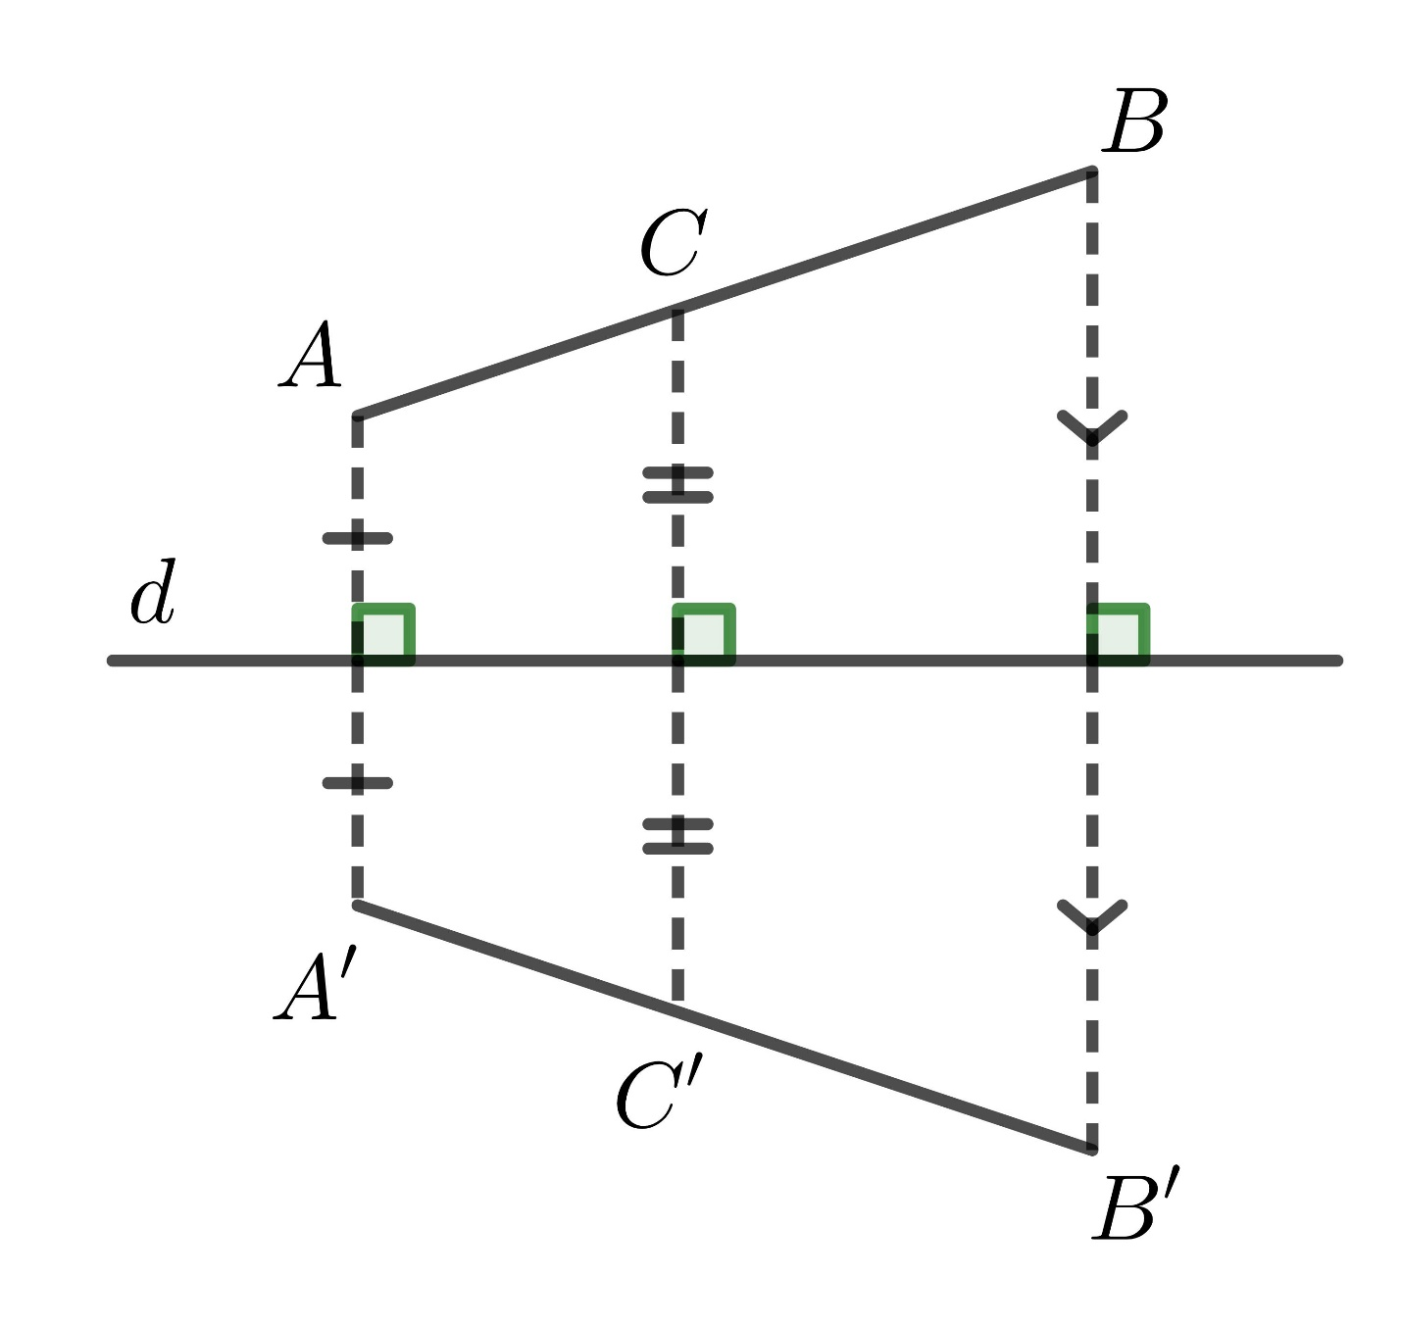
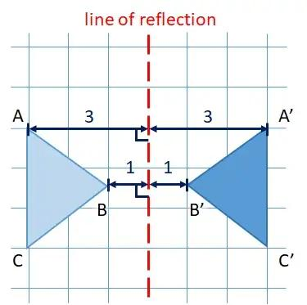
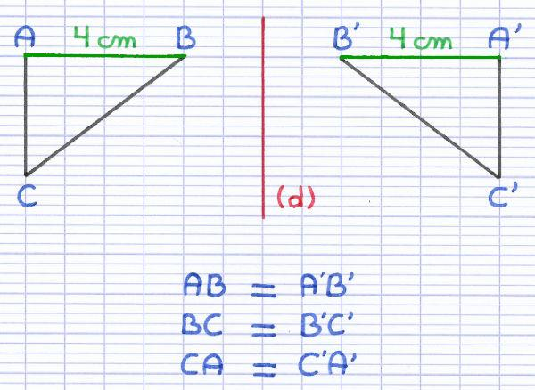
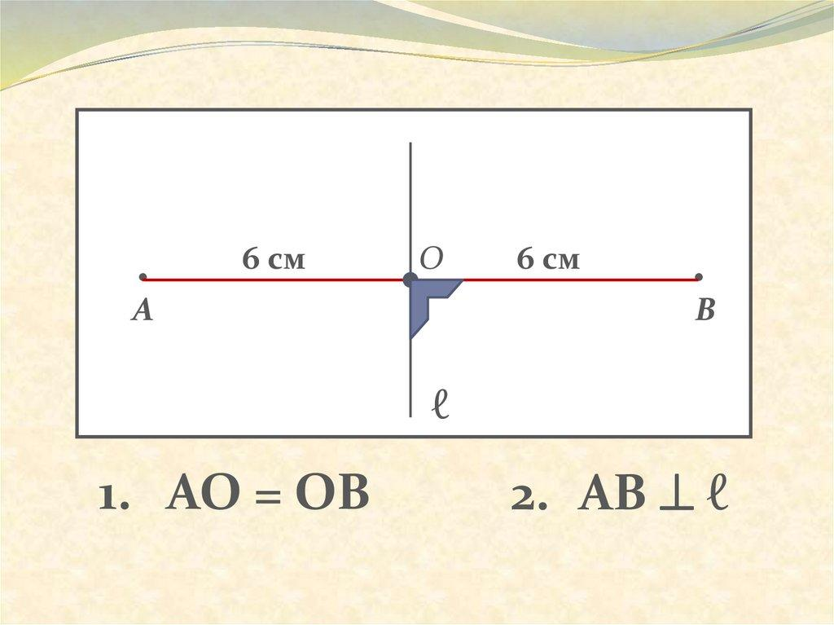
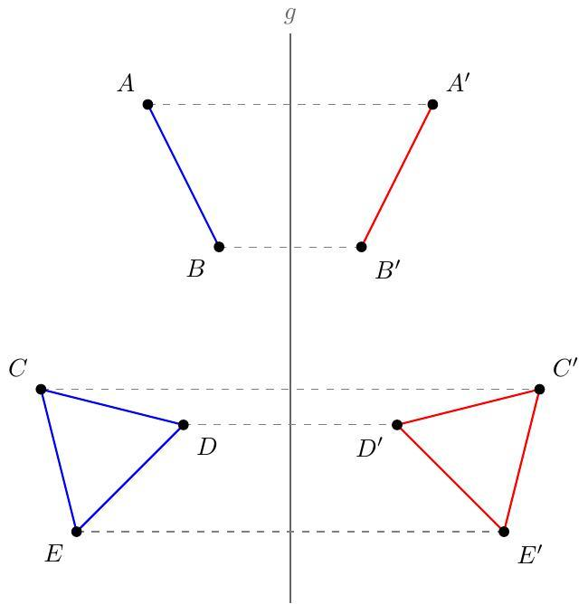
If reflection maps:
$$\overset{‾}{AB}→\overset{‾}{CD},$$
then:
$$\boxed{AB=CD}.$$
This occurs because an isometry preserves distance.

Equality from Parallel Lines
# Source: AI Source: Provided by: [Data Path: Persons Table -> ID Column: 1, Name_En Column: Motasem Essam] -> From: [ChatGPT] on [7/25/2026]
Parallel-line configurations can produce equal segments when additional conditions are present.
For example, in a parallelogram:
$$AB∥CD$$
and:
$$AD∥BC.$$
Opposite sides are equal:
$$\boxed{AB=CD} \\ \boxed{AD=BC}.$$
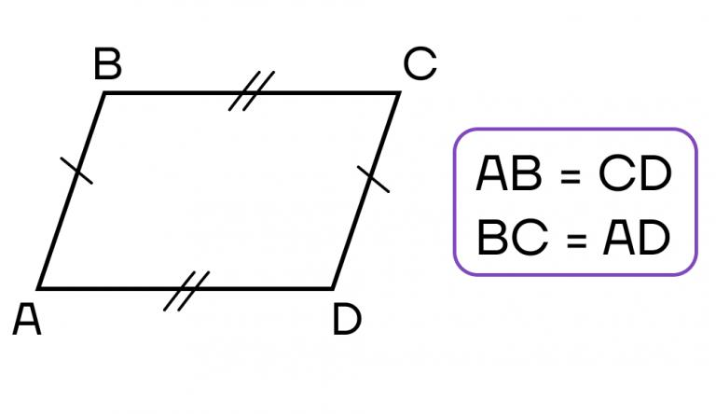
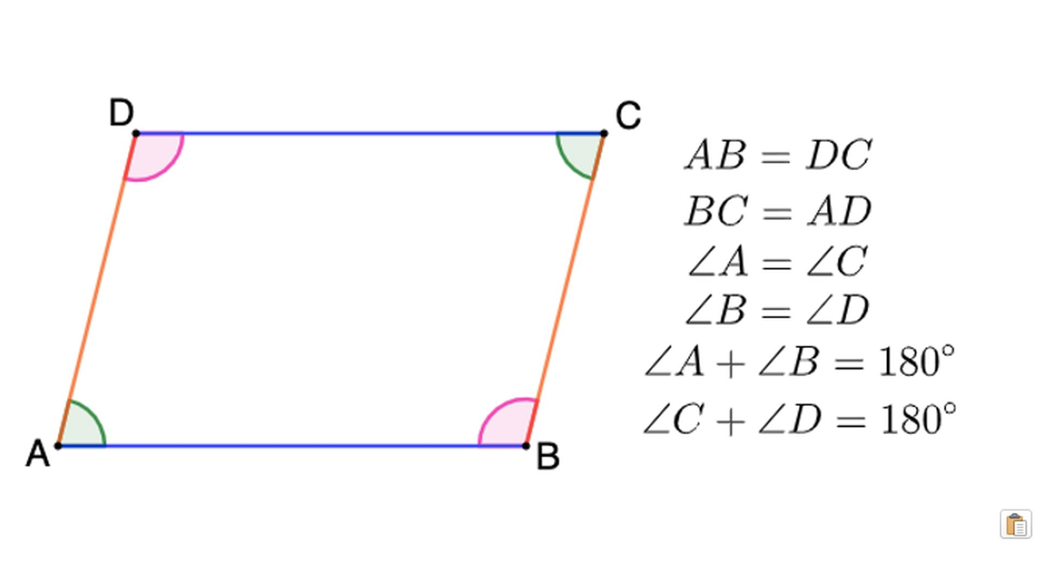
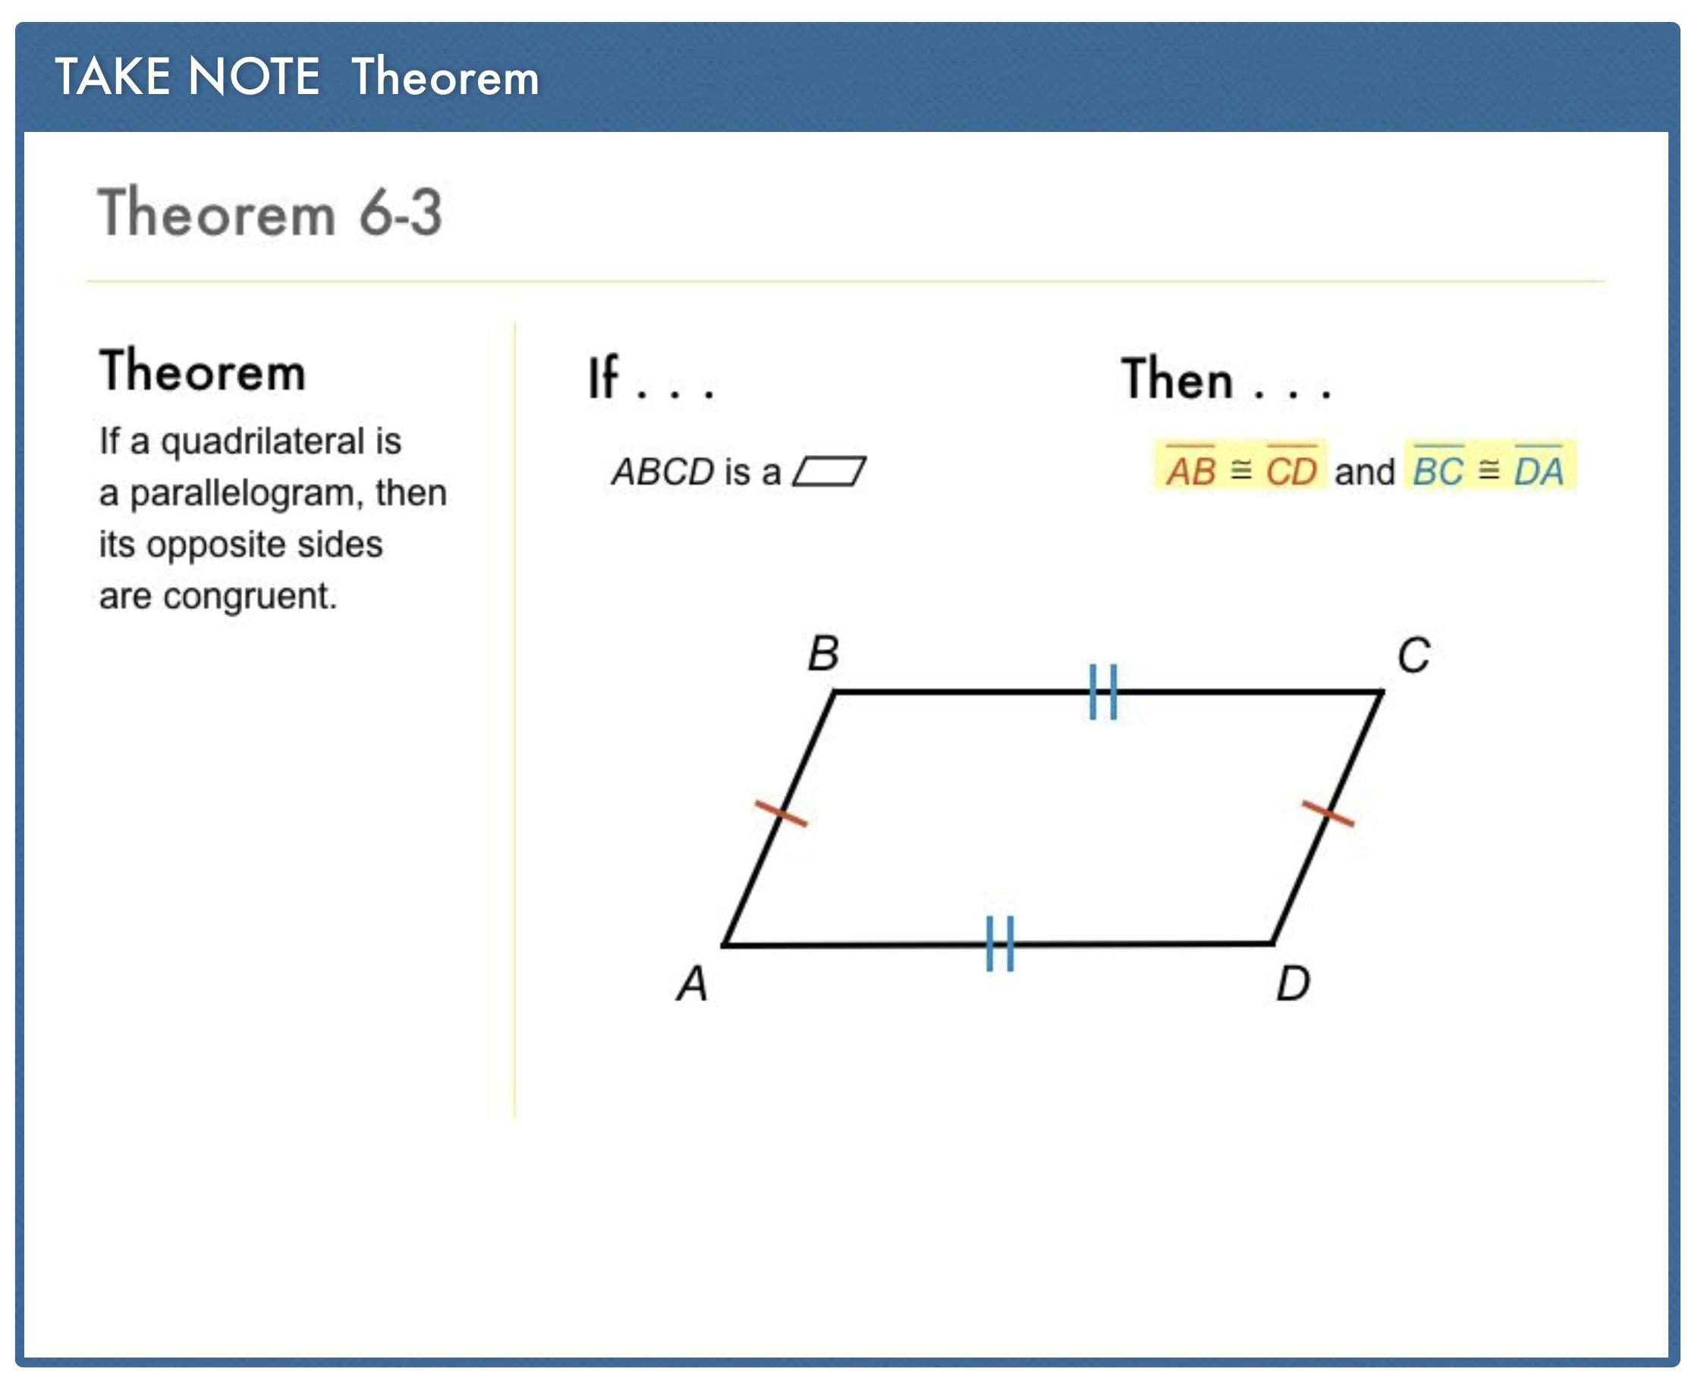
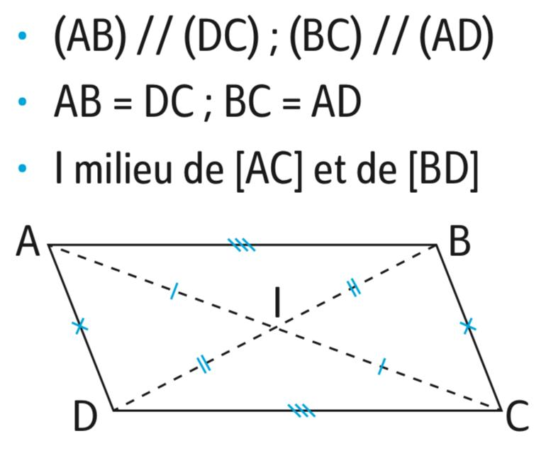
However, parallelism alone does not generally imply equal lengths.
The complete geometric configuration matters.

Equality from Similarity
# Source: AI Source: Provided by: [Data Path: Persons Table -> ID Column: 1, Name_En Column: Motasem Essam] -> From: [ChatGPT] on [7/25/2026]
Similarity generally produces proportional segment lengths rather than equal segment lengths.
If:
$$△ABC∼△DEF,$$
then:
$$\frac{AB}{DE}=\frac{BC}{EF}=\frac{AC}{DF}.$$
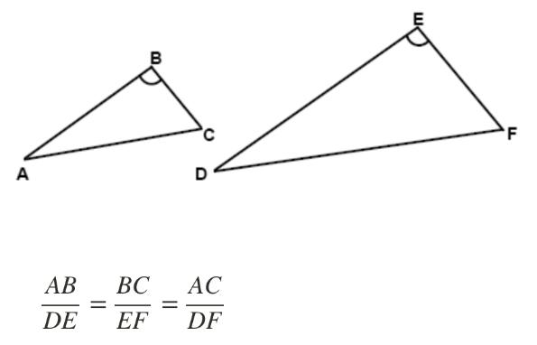
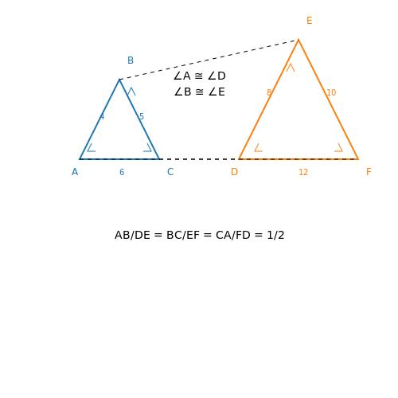
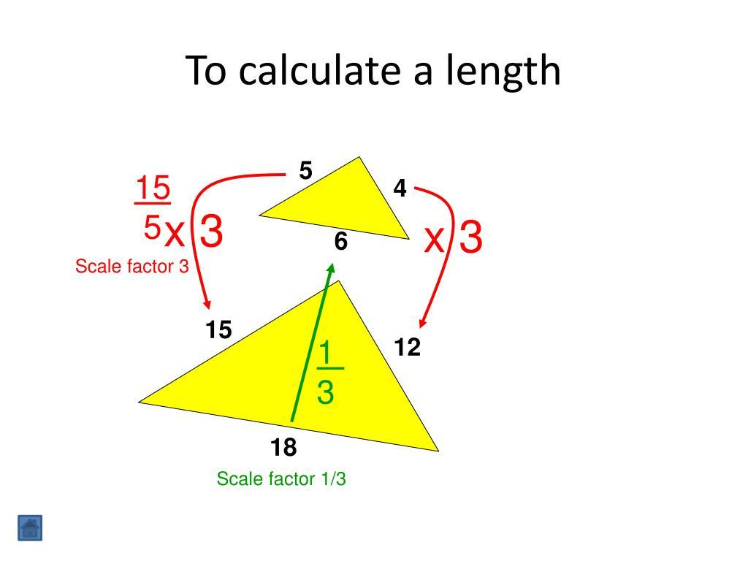
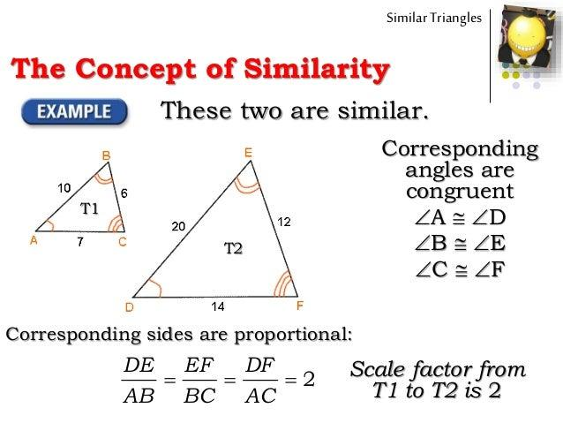
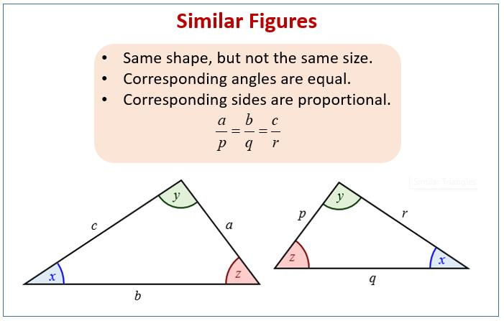
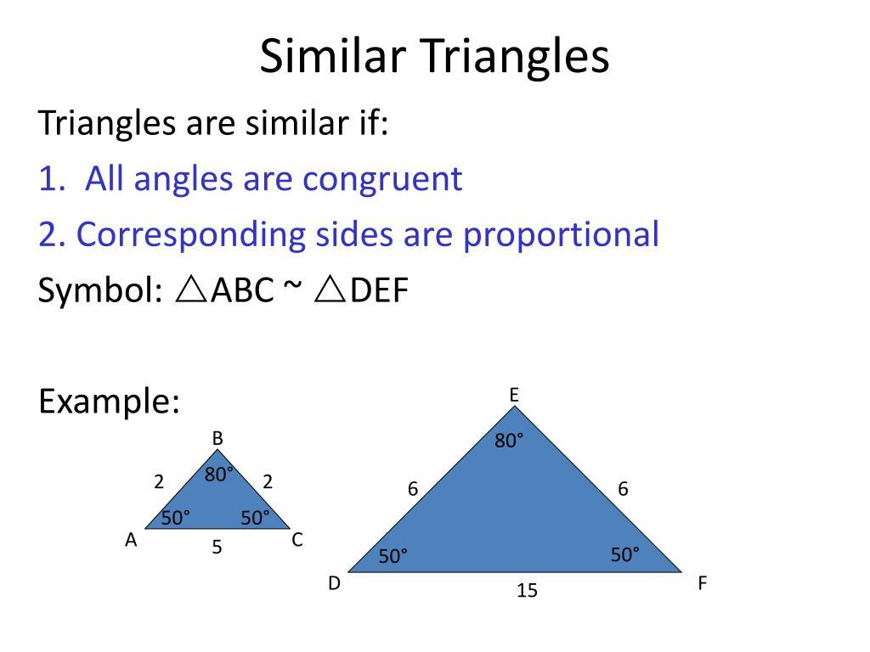
If the scale factor is:
$$k=1,$$
then:
$$AB=DE, BC=EF, AC=DF.$$
So:
$$\boxed{\text{Similarity + scale factor }1→\text{Segment-Length Equality}}$$
But ordinary similarity does not imply equal lengths.

Equality Established Algebraically
# Source: AI Source: Provided by: [Data Path: Persons Table -> ID Column: 1, Name_En Column: Motasem Essam] -> From: [ChatGPT] on [7/25/2026]
Segment equality can also be established by calculating or simplifying their lengths.
Suppose:
$$AB=2x+4$$
and:
$$CD=3x-1.$$
If we know:
$$AB=CD,$$
then:
$$2x+4=3x-1.$$
Therefore:
$$x=5.$$
Substitute:
$$AB=2\left(5\right)+4=14$$
and:
$$CD=3\left(5\right)-1=14.$$
Thus:
$$\boxed{AB=CD=14}.$$

Equality from the Distance Formula
In coordinate geometry, segment equality can be established by comparing distances.
For:
$$A\left(x_{1} , y_{1}\right), B\left(x_{2} , y_{2}\right),$$
the length is:
$$\boxed{AB=\sqrt{{\left(x_{2}-x_{1}\right)}^{2}+{\left(y_{2}-y_{1}\right)}^{2}}}$$
Suppose:
$$A=\left(0 , 0\right), B=\left(3 , 4\right).$$
Then:
$$AB=\sqrt{3^{2}+4^{2}}=5.$$
Suppose:
$$C=\left(1 , 1\right), D=\left(4 , 5\right).$$
Then:
$$CD=\sqrt{{\left(4-1\right)}^{2}+{\left(5-1\right)}^{2}} \\ =\sqrt{3^{2}+4^{2}}=5.$$
Therefore:
$$\boxed{AB=CD}.$$

Equality from the Pythagorean Theorem
# Source: AI Source: Provided by: [Data Path: Persons Table -> ID Column: 1, Name_En Column: Motasem Essam] -> From: [ChatGPT] on [7/25/2026]
Segment equality can sometimes be established by calculating two lengths using right-triangle relationships.
For example, if:
$$AB^{2}=3^{2}+4^{2}=25,$$
then:
$$AB=5.$$
If another segment satisfies:
$$CD^{2}=25,$$
then:
$$CD=5.$$
Therefore:
$$\boxed{AB=CD}.$$

Equality of Multiple Segments
# Source: AI Source: Provided by: [Data Path: Persons Table -> ID Column: 1, Name_En Column: Motasem Essam] -> From: [ChatGPT] on [7/25/2026]
More than two segments can have equal lengths.
For example, in a regular polygon:
$$\boxed{AB=BC=CD=DE=EA}$$
for a regular pentagon.
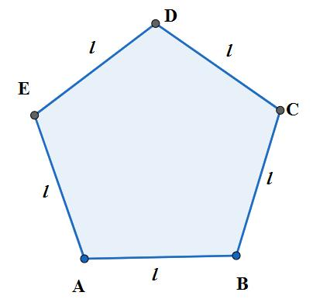
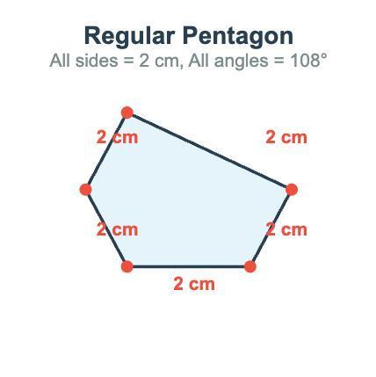
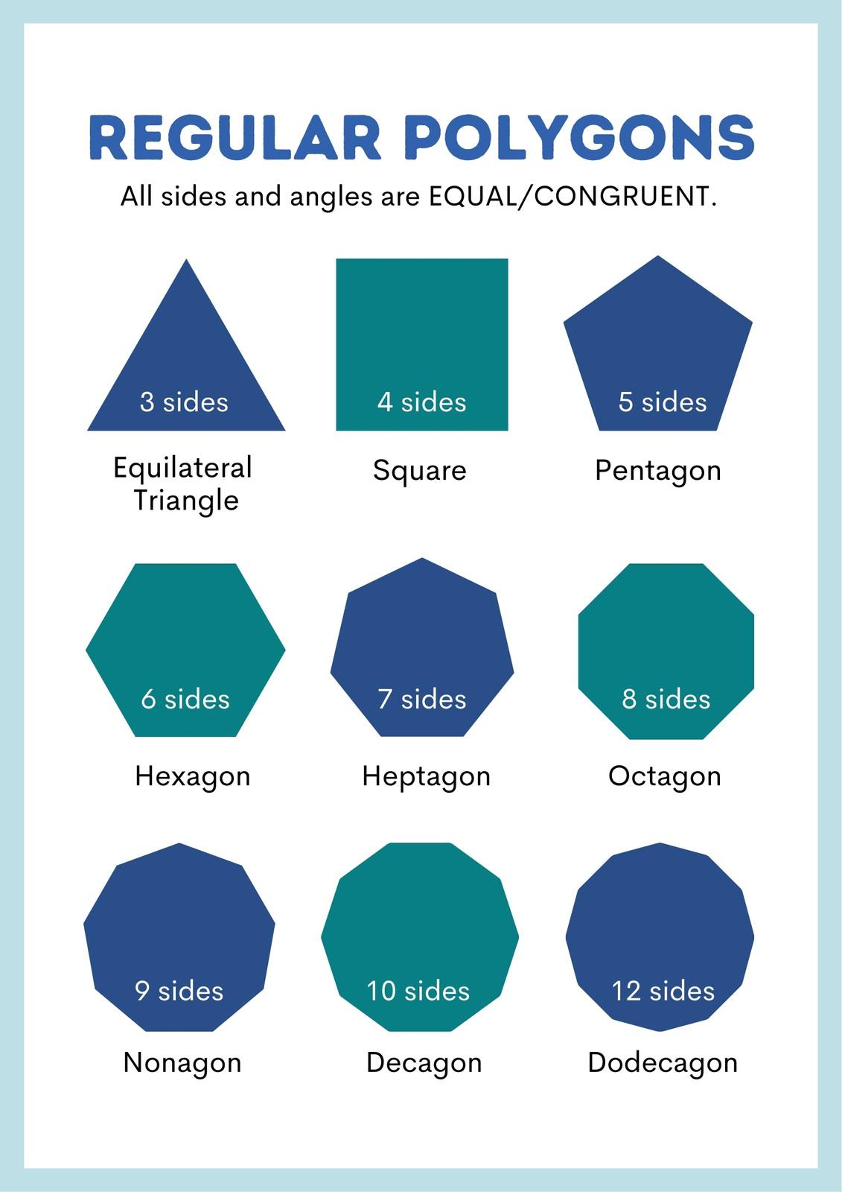
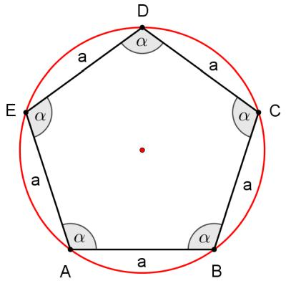
This can be expressed as:
$$AB=BC=CD=DE=EA=s.$$

Equality vs. Congruence
# Source: AI Source: Provided by: [Data Path: Persons Table -> ID Column: 1, Name_En Column: Motasem Essam] -> From: [ChatGPT] on [7/25/2026]
These concepts are related but should not be confused.
Segment-Length Equality
$$\boxed{AB=CD}$$
means:
The numerical lengths are equal.
Segment Congruence
$$\boxed{\overset{‾}{AB}≅\overset{‾}{CD}}$$
means:
The two line segments are congruent.
For line segments:
$$\boxed{\overset{‾}{AB}≅\overset{‾}{CD} ⟺ AB=CD}$$

Equality vs. Approximation
# Source: AI Source: Provided by: [Data Path: Persons Table -> ID Column: 1, Name_En Column: Motasem Essam] -> From: [ChatGPT] on [7/25/2026]
Exact equality:
$$\boxed{AB=CD}$$
Approximate equality:
$$AB≈CD.$$
For example:
$$AB=\sqrt{2}$$
and:
$$CD=1.414.$$
These may be numerically close, but they are not necessarily exactly equal.
Therefore:
$$\boxed{=≠≈}$$

Segment-Length Equality in Proofs
# Source: AI Source: Provided by: [Data Path: Persons Table -> ID Column: 1, Name_En Column: Motasem Essam] -> From: [ChatGPT] on [7/25/2026]
Segment equality is frequently used as a given, definition, or conclusion in geometric proofs.
Example:
Given: $M$is the midpoint of $AB$.
Therefore:
$$AM=MB.$$
Then this equality can be used to prove other results.
For example:
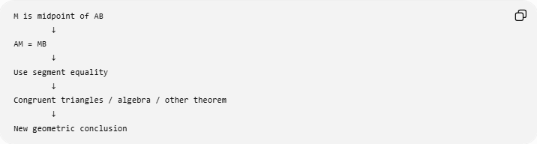
M is midpoint of AB
↓
AM = MB
↓
Use segment equality
↓
Congruent triangles / algebra / other theorem
↓
New geometric conclusion

Common Sources of Segment-Length Equality
# Source: AI Source: Provided by: [Data Path: Persons Table -> ID Column: 1, Name_En Column: Motasem Essam] -> From: [ChatGPT] on [7/25/2026]
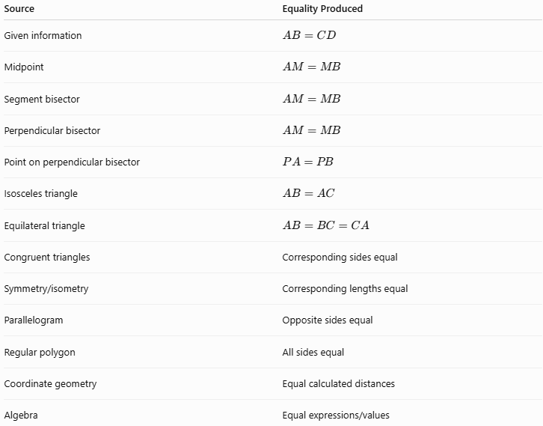
Source | Equality Produced
Given information | $$AB=CD$$
Midpoint | $$AM=MB$$
Segment bisector | $$AM=MB$$
Perpendicular bisector | $$AM=MB$$
Point on perpendicular bisector | $$PA=PB$$
Isosceles triangle | $$AB=AC$$
Equilateral triangle | $$AB=BC=CA$$
Congruent triangles | Corresponding sides equal
Symmetry/isometry | Corresponding lengths equal
Parallelogram | Opposite sides equal
Regular polygon | All sides equal
Coordinate geometry | Equal calculated distances
Algebra | Equal expressions/values

Classification Summary
# Source: AI Source: Provided by: [Data Path: Persons Table -> ID Column: 1, Name_En Column: Motasem Essam] -> From: [ChatGPT] on [7/25/2026]
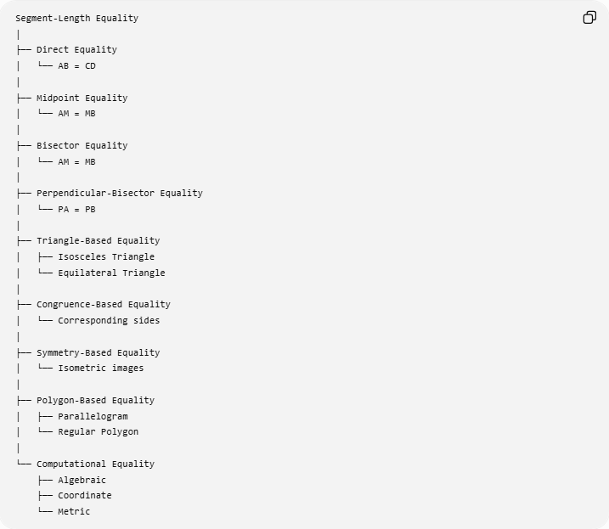
Segment-Length Equality
│
├── Direct Equality
│ └── AB = CD
│
├── Midpoint Equality
│ └── AM = MB
│
├── Bisector Equality
│ └── AM = MB
│
├── Perpendicular-Bisector Equality
│ └── PA = PB
│
├── Triangle-Based Equality
│ ├── Isosceles Triangle
│ └── Equilateral Triangle
│
├── Congruence-Based Equality
│ └── Corresponding sides
│
├── Symmetry-Based Equality
│ └── Isometric images
│
├── Polygon-Based Equality
│ ├── Parallelogram
│ └── Regular Polygon
│
└── Computational Equality
├── Algebraic
├── Coordinate
└── Metric

Key Formulas and Relationships
# Source: AI Source: Provided by: [Data Path: Persons Table -> ID Column: 1, Name_En Column: Motasem Essam] -> From: [ChatGPT] on [7/25/2026]
Basic equality
$$\boxed{AB=CD}$$
Midpoint
$$\boxed{AM=MB}$$
Perpendicular bisector
$$\boxed{PA=PB}$$
for $P$on the perpendicular bisector of $AB$.
Isosceles triangle
$$\boxed{AB=AC}$$
Equilateral triangle
$$\boxed{AB=BC=CA}$$
Parallelogram
$$\boxed{AB=CD, AD=BC}$$
Regular polygon
$$\boxed{s_{1}=s_{2}=⋯=s_{n}}$$
Coordinate distance
$$\boxed{AB=\sqrt{{\left(x_{2}-x_{1}\right)}^{2}+{\left(y_{2}-y_{1}\right)}^{2}}}$$

Key Points
# Source: AI Source: Provided by: [Data Path: Persons Table -> ID Column: 1, Name_En Column: Motasem Essam] -> From: [ChatGPT] on [7/25/2026]
- Segment-Length Equality means two or more segments have exactly the same length.
- It is written:
$$\boxed{AB=CD}.$$
- Equal segments do not have to occupy the same position or direction.
- A midpoint creates two equal segments:
$$AM=MB.$$
- A perpendicular bisector creates equal halves and equal distances from its points to the endpoints.
- Isosceles and equilateral triangles provide common examples of segment equality.
- Congruent triangles produce equal corresponding side lengths.
- Symmetry and other isometries preserve segment lengths.
- Similarity normally produces proportional lengths, not equal lengths, unless the scale factor is $1$.
- Coordinate geometry and algebra can be used to establish exact segment equality.
- Segment-length equality compares measurements, while segment congruence describes the relationship between the geometric segments.

Conclusion
# Source: AI Source: Provided by: [Data Path: Persons Table -> ID Column: 1, Name_En Column: Motasem Essam] -> From: [ChatGPT] on [7/25/2026]
Segment-Length Equality is one of the fundamental forms of Geometric Equality. It expresses the exact relationship:
$$\boxed{AB=CD}$$
meaning that the two segments have the same length.
It can arise directly from given information or from geometric properties such as midpoints, bisectors, perpendicular bisectors, isosceles triangles, equilateral triangles, congruence, symmetry, and regular figures.
$$\boxed{\text{Segment-Length Equality}=\text{Exact Equality of Segment Measures}}$$

